**Wireless Sensor Ad-hoc Network**

Session Fall (2011-2015)

**Program**

**Bachelors of Science in Telecommunication**

## Submitted By:

**Wajid Ali Khan HU (1542) 2011**

**Syed Nadeem HU (1579) 2011**

**Muhammad Tariq Khan HU (1545) 2011**

**Syed Nisar Yousaf Sherazi HU (1512) 2011**

**Supervised By:**

**Engr. Muhammad Faheem Awan**

**Lecturer, Telecom Department**

**DEPARTMENT OF TELECOMMUNICATION**

**HAZARA UNIVERSITY MANSEHRA**

**August 2015**

**FINAL APPROVAL**

It is certified that the project report submitted by Wajid Ali Khan, Syed Nadeem, Muhammad Tariq Khan and Syed Nisar Yousaf Sherazi for the fulfilment of the requirement of “Bachelor’s Degree in Telecommunication” is approved.

**Committee:**

Supervisor:

Engr. Muhammad Faheem Awan

Lecturer

Department of Information Technology

Hazara University

Mansehra (Garden Campus).

External Supervisor:

Dated:

Head of Department:

**NOOR-UL-AMEEN**

Head of Department

Information Technology

Hazara University

**DEDICATION**

This work is dedicated to our Parents and Teachers for their support and guidance at all stages. We also dedicate this work to all class fellows.

**DECLARATION**

We declare that this thesis is our own work and has not been submitted in any form for another degree or diploma at any university or other institution of tertiary education.

Name: Wajid Ali Khan

Signature:

Name: Syed Nadeem

Signature:

Name: Muhammad Tariq Khan

Signature:

Name: Syed Nisar Yousaf Sherazi

Signature:

**ACKNOWLEDGMENT**

First and foremost, we would like to express our warmest gratitude and respect to **Engr. Muhammmad Faheem Awan** for his guidance and motivation throughout this year. He gives us supports and advices in completing this final year project. He patiently guided us to find solutions when we faced problems in this year. He encourages us to explore new thing and think out of the box to overcome all the problems. He made our way to the steps of learning by different prospective. We are thankful to him for his guidance and motivation throughout this year. He encourages us to explore new things. Lastly, my appreciation goes to my family members and friends who have fully support me all this while.

**ABSTRACT**

A wireless sensor network (WSN) consists of sensors which are densely distributed to monitor physical or environmental conditions, such as temperature, motion etc. The temperature sensor data and motion sensor data is transmitted to network coordinator which is heart of the wireless personal area network. Ad-hoc is defined as “Arranged or happening when necessary and not planned in advanced” according to oxfords advanced learners dictionary. This gives an explanation of what ad- hoc networks are is to say networks setup on the fly for a special purpose. Furthermore ad- hoc networks are usually such networks that are setup for onetime Occurrences such as conferences or military operations. This can be paraphrased into the following definition an ad-hoc network is a flexible and adaptive network with no fixed infrastructure.

The Wireless Ad-hoc Networks do not have gateway, every node can act as the gateway. Although Ad-hoc Networks is a fundamental flawed architecture. The main reason for the argument is that Ad-hoc Networks are almost never used in practice, almost every wireless network nodes communicate to base-station and access points instead of co-operating to forward packets hop-by-hop.

**Contents**

Chapter 1 1

INTRODUCTION 1

1.1 Overview 1

1.2 Statement of Problem 1

1.3 Specifications of proposed solution 1

1.4 Wireless Sensor Network 1

1.5 Applications of the project 2

Chapter 2 3

LITERATURE REVIEW 3

2.1 Related Technologies 3

2.1.1 Global System for Mobile Communication (GSM) 4

2.1.2 General Packet Radio Service (GPRS) 4

2.1. 3 Wireless Application Protocol (WAP) 4

2.2 Related Projects 5

2.2.1 Wireless Network Based Wireless SCADA 5

2.2.2 Wireless Sensors Based System for Home Energy Consumption 5

2.3 Related Studies/Research 6

2.3.1 Distributed Sensor network 6

2.3.2 Data integration and Sensor Web 7

2.3.3 In-network processing 7

Chapter 3 8

PROJECT DESIGN AND IMPLEMENTATION 8

3.1 Motion sensor: 9

3.2 Working Mechanism of ZigBee 10

Chapter 4 11

TOOLS AND TECHNIQUES 11

4.1 Hardware used with technical specifications 11

4.1.1 ZigBee 11

4.1.1.1 IEEE 802.15.4 12

4.1.1.2 ZigBee Applications 13

4.1.1.3 The ZigBee Protocol 13

4.1.1.4 The ZigBee Advantage 13

4.1.1.5 ZigBee protocol features include 13

4.1.1.6 Mesh Networks 13

4.1.2 Single Pole Double Throw (SPDT) 14

4.1.3 Capacitors 15

4.1.3.1 Capacitor Construction 16

4.1.3.2 Voltage Rating of a Capacitor 17

4.1.4 Arduino Uno 17

4.1.4.1 ATmega328 19

4.1.5 7805 IC 20

4.1.5.1 Features of 7805 IC 21

4.1.5.2 Pin Description 22

4.1.5.3 7805 IC working 23

4.1.6 78L12z IC 24

4.1.7 2n222 Transistor 25

4.1.7.1 Switching 26

4.1.7.2 Amplification 26

4.1.7.3 Operational characteristics 26

4.1.7.4 Features 26

4.1.7.5 Characteristics 26

4.1.7.6 Specifications 27

4.1.8 Resistor 28

4.1.8.1 Dimensions and material affects 28

4.1.8.2 Resistor color code 28

4.1.8.3 Pull-up resistor 29

4.1.8.4 Pull-down resistor 29

4.1.9 Led 29

4.1.10 LDR 29

4.1.10.1 Characteristics of LDR 30

4.10.1.2 Types of Light Dependent Resistors 31

4.1.11 Motion Sensor PIR 31

4.1.11.1 Overview 31

4.1.11.2 Description 31

4.1.11.3 Technical Details 32

4.1.11.4 Working of motion Sensors 32

4.1.11.5 Uses 33

4.1.11.6 Dimensions 33

4.1.11.7 Some Basic Stats 34

4.1.12 Temperature Sensor LM35 34

4.1.12.1 Features 35

4.1.12.2 Pin Description 35

4.1.12.3 Working 35

4.1.13 Voltage Regulator 36

4.2 Software Specifications 37

4.2.1 Arduino IDE 37

4.2.2 Proteus Software 40

Chapter 5 41

Results 41

CHAPTER 6 43

Conclussion 43

REFERENCES 45

**List of Acronyms**

WSN Wireless sensor network

GSM Global system for mobile

GPRS General Packet Radio service

SPDT Single Pole double throw

**List of Figures**

|  |  |  |
| --- | --- | --- |
| **Figure No** | **Title** | **Page No** |
| Figure 1.1 | Wireless Sensor Network | 2 |
| Figure 2.1 | Wireless Network Based Wireless SCADA | 5 |
| Figure 2.2 | Wireless Sensors Based System for Home Energy Consumption | 6 |
| Figure 3.1 | Schematic Sketch for temperature sensor and light intensity | 8 |
| Figure 3.2 | PCB Designing | 9 |
| Figure 3.3 | Schematic Simulation Sketch for Motion sensor | 10 |
| Figure 4.1 | Mesh network | 14 |
| Figure 4.2 | Single Pole Double Throw (SPDT) Relay | 15 |
| Figure 4.3 | Capacitor | 15 |
| Figure 4.4 | Arduino Uno | 18 |
| Figure 4.5 | ATmega 328 | 20 |
| Figure 4.6 | 7805 IC | 21 |
| Figure 4.7 | Pin Description of 7805 IC | 22 |
| Figure 4.8 | 7805 IC working | 23 |
| Figure 4.9 | Base Emitting Voltage via Temperature | 24 |
| Figure 4.10 | Circuit Diagram of 78L12z IC | 25 |
| Figure 4.11 | Resistor | 28 |
| Figure 4.12 | Light emitting diode | 29 |
| Figure 4.13 | Light dependent resistor | 30 |
| Figure 4.14 | Graphical Output of LDR | 30 |
| Figure 4.15 | Motion Sensor PIR | 32 |
| Figure 4.16 | Temperature Sensor LM35 | 35 |
| Figure 4.17 | Circuit Diagram of Temperature Sensor LM35 | 36 |
| Figure 4.18 | Voltage Regulator | 37 |
| Figure 4.19 | An Arduino Uno | 37 |
| Figure 4.20 | An A-to-B USB Cable | 38 |
| Figure 4.21 | Step 1 of Installation | 39 |
| Figure 4.22 | Step 2 of Installation | 39 |

**List of Tables**

|  |  |  |
| --- | --- | --- |
| **Table No** | **Title** | **Page No** |
| Table 4.1 | Arduino Uno Specifications | 18 |
| Table 4.2 | ATmega328 Specifications | 20 |
| Table 4.3 | 7805 IC Specifications | 22 |
| Table 4.4 | Specifications 2n222 transistor | 28 |
| Table 4.5 | Pin Description of Temperature Sensor LM35 | 35 |
| Table 4.6 | Verification and uploading | 40 |

# Chapter 1

# INTRODUCTION

## 1.1 Overview

With the advent of low-power wireless networking, new possibilities emerged for distributed sensing applications. These technologies led to the implementation of wireless sensor networks, allowing easily configured, adaptable sensors to be placed almost anywhere such as motion sensors and temperature sensor. This network system consists of ZigBee which is less power consuming.

## 1.2 Statement of Problem

Mostly project that are done were based on either motion sensor or temperature sensor. In our project we are designing such network system that will consist of both temperature and motion sensors and will transmit data through ZigBee which is less power consuming as compared to others.

## 1.3 Specifications of proposed solution

We are developing a networking system that will open up new opportunities for continuous monitoring of assisted and independent-living residents. While preserving resident comfort and privacy, the network manages continuous transmitting and receiving of data.

## 1.4 Wireless Sensor Network

Wireless sensor networks consist of distributed, wirelessly enabled embedded devices capable of employing a variety of electronic sensors. Each node in a wireless sensor network is equipped with one or more sensors in addition to a microcontroller, wireless transceiver, and energy source. The microcontroller functions with the electronic sensors as well as the transceiver to form an efficient system for relaying small amounts of important data with minimal power consumption. The most attractive feature of wireless sensor network is their autonomy.

When deployed in the field, the microprocessor automatically initializes communication with every other node in range, creating an ad hoc mesh network for relaying information to and from the gateway node. This negates the need for costly and ungainly wiring between nodes, instead relying on the flexibility of mesh networking algorithms to transport information from node to node. This allows nodes to be deployed in almost any location. Coupled with the almost limitless supply of available sensor modules, the flexibility offered by wireless sensor networks offers much potential for application-specific solutions.

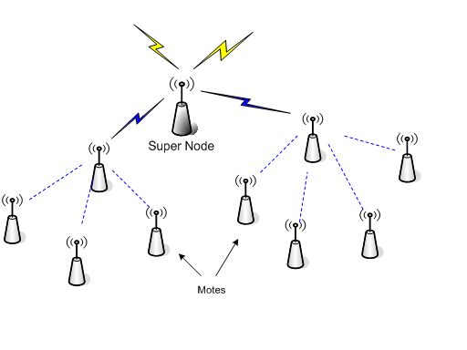Figure 1.1: Wireless Sensor Network

## 1.5 Applications of the project

* Environmental monitoring.
* Acoustic detection.
* Seismic Detection.
* Military surveillance.
* Inventory tracking.
* Medical monitoring.
* Smart spaces.
* Process Monitoring.

# Chapter 2

# LITERATURE REVIEW

This chapter introduces the basic concept which will be used to implement the wireless network system. This chapter also reviews the previous projects which are related to wireless network system.

The research on wireless ad hoc networks has experienced a rapid growth over the last few years. Unique properties of ad hoc networks, such as operation without pre-existing infrastructure, fast deployment, and self-configuration, make them suitable for communication in tactical operations, search and rescue missions, and home networking. While most studies in this area have concentrated on the design of routing protocols, medium access control protocols, and security issues, we investigate the efficiency of energy consumption of wireless ad hoc networks in this work. Due to their portability and their deployment in potentially harsh scenarios, nodes in ad hoc networks are usually powered by batteries with finite capacity. It is always desirable to extend the lifetime of ad hoc network nodes without sacrificing their functionality. Thus, the study of energy-efficient mechanisms is of significant importance.

Recently, wireless sensor networks have been attracting a great deal of commercial and research interest [1, 2]. In particular, practical emergence of wireless ad-hoc networks is widely considered revolutionary both in terms of paradigm shift as well as enabler of new applications. In ad-hoc networks there is no fixed network infrastructure (such as in cellular phone networks) and therefore they can be deployed and adapted much more rapidly. Furthermore, integration of inexpensive, power efficient and reliable sensors in nodes of wireless ad-hoc networks, with significant computational and communication resources, opens new research and engineering vistas.

In wireless ad hoc networks, the major energy consumption at each node is due to system operation, data processing, and wireless transmission and reception. While there are studies on increasing battery capacity and reducing the energy consumption of system operation and data processing, a study on energy consumption economy of radio transceivers is also necessary to achieve a more energy-efficient system design [3].

At present, agent-based modelling and simulation is the only paradigm which allows the simulation of complex behaviour in the environments of wireless sensors (such as flocking) [4]. Agent-based simulation of wireless sensor and ad hoc networks is a relatively new paradigm. Agent-based modelling was originally based on social simulation.

## 2.1Related Technologies

Ad-hoc Networks (MANET) have no fixed routers, every node could be router. All nodes are capable of movement and can be connected dynamically in arbitrary manner. The responsibilities for organizing and controlling the network are distributed among the terminals themselves. The entire network is ad-hoc, and the individual terminals are allowed to move freely. In this type of networks, some pairs of terminals may not be able to communicate directly with each other and have to relay on some terminals so that the messages are de livered to their destinations. Such networks are often referred to as multi-hoper store-and forward networks. The nodes of these networks function as routers, which discover and maintain routes to other nodes in the networks. The nodes may be located in or on airplanes, ships, trucks, cars, perhaps even on people or very small devices. Mobile Ad-hoc Networks are supposed to be used for disaster recovery, battlefield communications, and rescue operations when the wired network is not available. It can provide a feasible means for ground communications and information access [5].

### 2.1.1Global System for Mobile Communication ([GSM](http://searchmobilecomputing.techtarget.com/definition/GSM))

GSM (Global System for Mobile Communications, originally Grouped Special Mobile), is a standard developed by the European Telecommunications Standards Institute (ETSI) to describe protocols for second-generation (2G) digital cellular networks used by mobile phones, first deployed in Finland in July 1991[6]. As of 2014 it has become the default global standard for mobile communications - with over 90% market share, operating in over 219 countries and territories.

 A digital mobile telephone system used in Europe and other parts of the world. GSM is a [digital](http://searchcio-midmarket.techtarget.com/definition/digital) mobile telephony system that is widely used in Europe and other parts of the world. GSM uses a variation of time division multiple access ([TDMA](http://searchnetworking.techtarget.com/definition/TDMA)) and is the most widely used of the three digital [wireless](http://searchmobilecomputing.techtarget.com/definition/wireless) telephony technologies (TDMA, GSM, and [CDMA](http://searchtelecom.techtarget.com/definition/CDMA)). GSM digitizes and compresses data, then sends it down a channel with two other streams of user data, each in its own time slot. It operates at either the 900 [MHz](http://searchnetworking.techtarget.com/definition/MHz) or 1800 MHz frequency band. GSM, together with other technologies, is part of the evolution of wireless mobile telecommunications that includes High-Speed Circuit-Switched Data ([HSCSD](http://searchnetworking.techtarget.com/definition/High-Speed-Circuit-Switched-Data)), General Packet Radio System ([GPRS](http://searchmobilecomputing.techtarget.com/definition/GPRS)), Enhanced Data GSM Environment ([EDGE](http://searchmobilecomputing.techtarget.com/definition/EDGE)), and Universal Mobile Telecommunications Service ([UMTS](http://searchmobilecomputing.techtarget.com/definition/UMTS)).

### 2.1.2General Packet Radio Service ([GPRS](http://searchmobilecomputing.techtarget.com/definition/GPRS))

General Packet Radio Services (GPRS) is a [packet](http://searchnetworking.techtarget.com/definition/packet)-based [wireless](http://searchmobilecomputing.techtarget.com/definition/wireless) communication service that promises data rates from 56 up to 114 [Kbps](http://searchnetworking.techtarget.com/definition/Kbps) and continuous connection to the Internet for [mobile phone](http://searchmobilecomputing.techtarget.com/definition/cellular-telephone) and computer users. The higher data rates allow users to take part in video conferences and interact with multimedia Web sites and similar applications using mobile [handheld](http://searchmobilecomputing.techtarget.com/definition/handheld) devices as well as notebook computers. GPRS is based on Global System for Mobile ([GSM](http://searchmobilecomputing.techtarget.com/definition/GSM)) communication and complements existing services such [circuit-switched](http://searchnetworking.techtarget.com/definition/circuit-switched) cellular phone connections and the Short Message Service ([SMS](http://searchmobilecomputing.techtarget.com/definition/Short-Message-Service)).

GPRS is the packet-oriented extension of GSM. This extension relies on the re-use of the radio infrastructure of GSM while introducing new network nodes in the core network providing the required packet switching functionality. GPRS is mainly intended to provide better service for Internet applications compared to existing circuit switched services of GSM. Certain timeslots of the TDMA frame can be statically or dynamically allocated to GPRS. These are denoted as Packet Data Channels (PDCH). GPRS provides mechanisms for efficient sharing of these radio resources by multiplexing several users over one PDCH as well as the possibility that one user transmits over several PDCH in parallel [7].

### 2.1. 3 Wireless Application Protocol ([WAP](http://searchmobilecomputing.techtarget.com/definition/WAP))

WAP (Wireless Application Protocol) is a specification for a set of communication [protocol](http://searchnetworking.techtarget.com/definition/protocol)s to standardize the way that [wireless](http://searchmobilecomputing.techtarget.com/definition/wireless) devices, such as [cellular telephones](http://searchmobilecomputing.techtarget.com/definition/cellular-telephone) and radio transceivers, can be used for Internet access, including e-mail, the World Wide Web, newsgroups, and [instant messaging](http://searchunifiedcommunications.techtarget.com/definition/instant-messaging). While Internet access has been possible in the past, different manufacturers have used different technologies. In the future, devices and service systems that use WAP will be able to interoperate.

The Wireless Application Protocol (WAP) is a protocol stack for wireless communication networks. WAP uses WTLS, a wireless variant of the SSL/TLS protocol, to secure the communication between the mobile phone and other parts of the WAP architecture [8].

## 2.2Related Projects

### 2.2.1 Wireless Network Based Wireless SCADA

SCADA stands for Supervisory Control and Data Acquisition. As the name indicates, it is not a full control system, but rather focuses on the supervisory level. As such, it is a purely software package that is positioned on top of hardware to which it is interfaced, in general via Programmable Logic Controllers (PLCs), or other commercial hardware modules. SCADA systems are used not only in most industrial processes: e.g. steel making, power generation (conventional and nuclear) and distribution, chemistry, but also in some experimental facilities such as nuclear fusion. The size of such plants range from a few 1000 to several 10 thousands input/output (I/O) channels. However, SCADA systems evolve rapidly and are now penetrating the market of plants with a number of I/O channels of several 100 K: we know of two cases of near to 1 M I/O channels currently under development. SCADA systems used to run on DOS, VMS and UNIX; in recent years all SCADA vendors have moved to NT. One product was found that also runs under LINUX.

In this project, using four [temperature sensors](https://www.elprocus.com/temperature-sensors-types-working-operation/) formed as wireless sensor networks projects, which are located in various places. If sensor temperature increases at the set point of the GUI, then the relay is made to switch ON and OFF the heater (a lamp load) to maintain the set temperature. In a SCADA system [different types of sensors](https://www.elprocus.com/types-analog-digital-sensors/) can be used for multiple control systems [9].

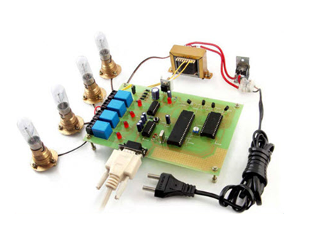

Figure 2.1: Wireless Network Based Wireless SCADA

### 2.2.2 Wireless Sensors Based System for Home Energy Consumption

 A Wireless-sensor-network-based system is used in high energy requiring home appliances like white goods, audio/video devices, communication equipment, air conditioning systems, heating and cooling system, which make our homes one of the most critical areas for the impact of energy consumption in the natural environment. ZigBee [home automation](https://www.elprocus.com/home-automation-systems-applications/) is a [simple mini project](https://www.elprocus.com/good-electronics-mini-projects-ideas/) for engineering students which can be implemented for automatic control of home appliances.

Sensor nodes can use up their limited energy supply carrying out computations and transmitting information in a wireless environment. As such, energy conserving forms of communication and computation are crucial as the node lifetime shows a strong dependence on the battery lifetime. In a multi-hop WSN, nodes play a dual role as data sender and data router. Therefore, malfunctioning of some sensor nodes due to power failure can cause significant topological changes and might require rerouting of packets and reorganization of the network [10].

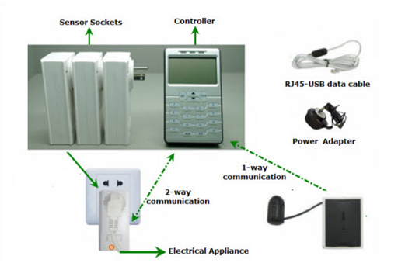

Figure 2.2: Wireless Sensors Based System for Home Energy Consumption

## 2.3Related Studies/Research

The work that has done related to this are:

### 2.3.1 Distributed Sensor network

If a centralised architecture is used in a sensor network and the central node fails, then the entire network will collapse, however the reliability of the sensor network can be increased by using distributed control architecture. Distributed control is used in WSNs for the following reasons:

1. Sensor nodes are prone to failure.
2. For better collection of data.
3. To provide nodes with backup in case of failure of the central node.

There is also no centralised body to allocate the resources and they have to be self-organized.

### 2.3.2 Data integration and Sensor Web

The data gathered from wireless sensor networks is usually saved in the form of numerical data in a central base station. Additionally, the [Open Geospatial Consortium](https://en.wikipedia.org/wiki/Open_Geospatial_Consortium) (OGC) is specifying standards for interoperability interfaces and metadata encodings that enable real time integration of heterogeneous sensor webs into the Internet, allowing any individual to monitor or control Wireless Sensor Networks through a Web Browser.

### 2.3.3In-network processing

To reduce communication costs some algorithms remove or reduce nodes' redundant sensor information and avoid forwarding data that is of no use. As nodes can inspect the data they forward, they can measure averages or directionality for example of readings from other nodes. For example, in sensing and monitoring applications, it is generally the case that neighbouring sensor nodes monitoring an environmental feature typically register similar values. This kind of data redundancy due to the spatial correlation between sensor observations inspires techniques for in-network data aggregation and mining.

# Chapter 3

# D:\my arduino projects3\wireless sensor network hazara university\LIGHT INTENSITY AND TEMPERATURE SECTION.pngPROJECT DESIGN AND IMPLEMENTATION

Figure 3.1: Schematic Sketch for temperature sensor and light intensity

The power supply is built around the voltage regulators 7812 and 7805. 78 represents the series and the last two digits represent the voltage. At the output of each regulator a bypass capacitor is used.

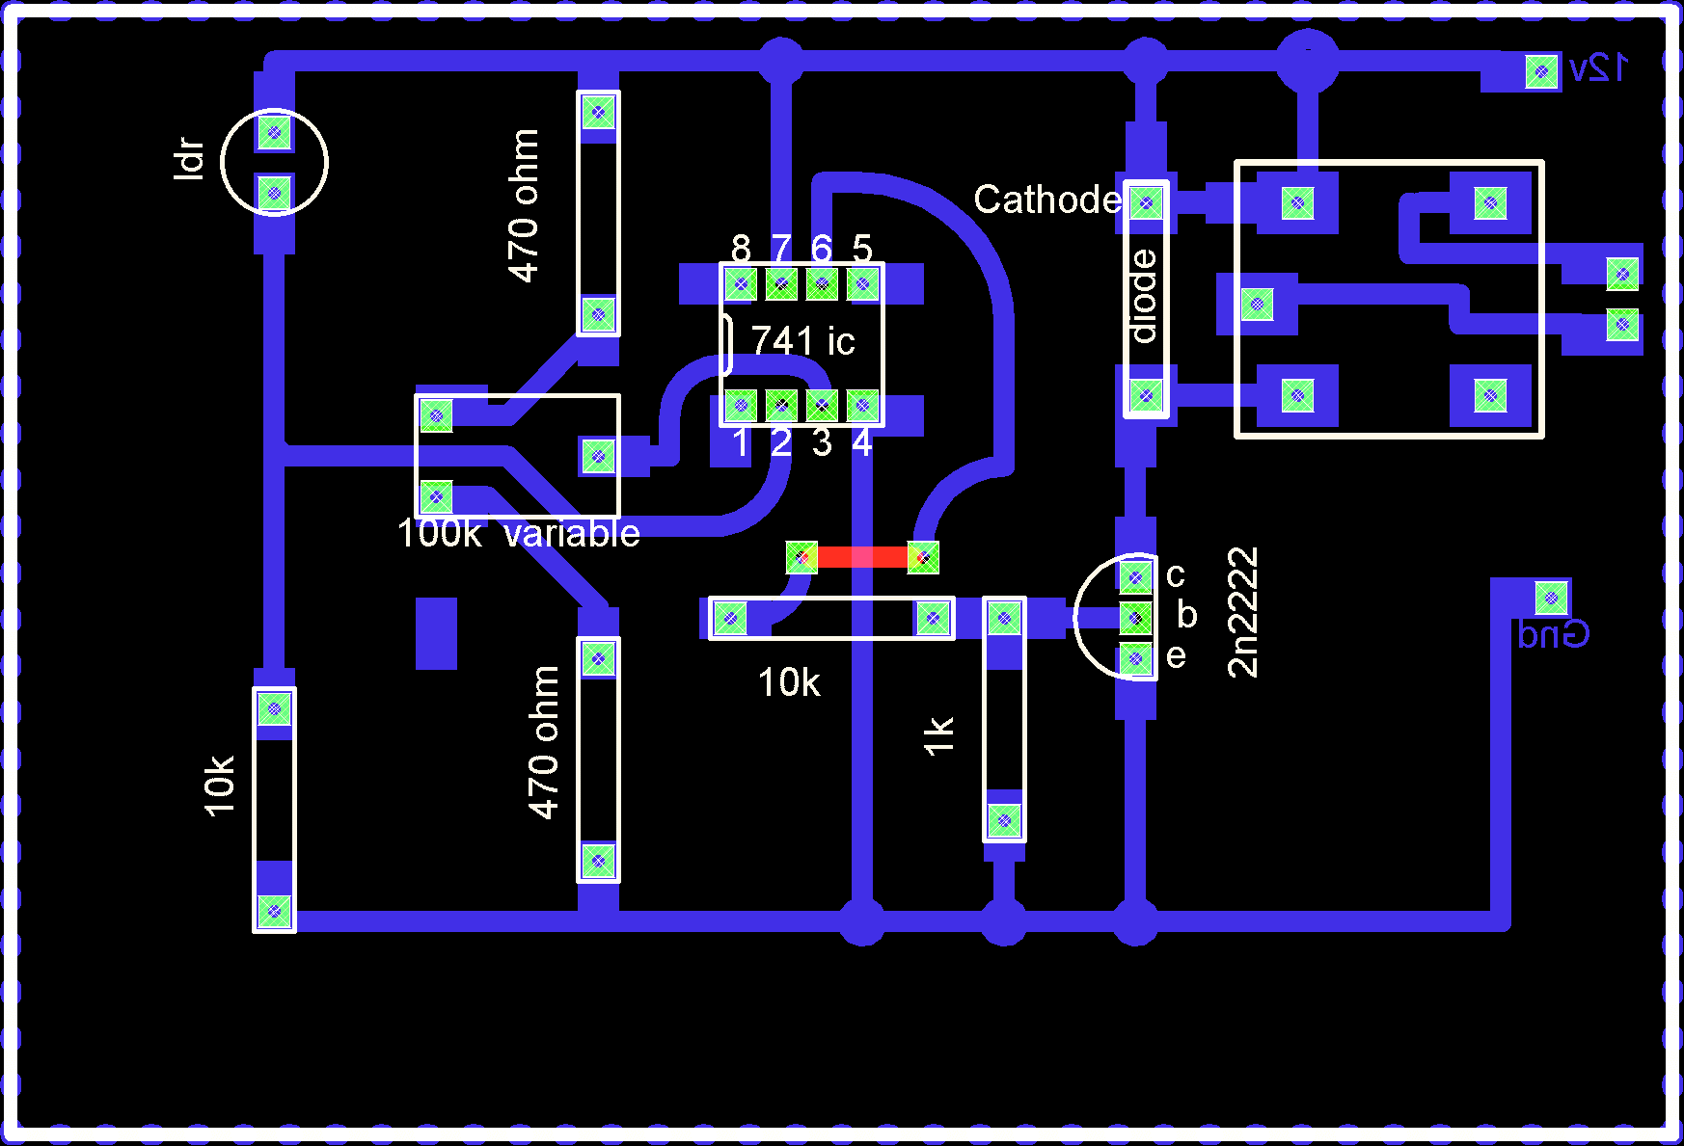The LDR and 10k resistor are used in series which makes a voltage divider. The divided voltage it fed to the 741 OPM which is used as the voltage comparator. The 100k ohm variable resistor is used to set the reference voltage. Through this variable resistor we set the light intensity. The two 470 ohm resistors are used for the protection of the variable resistor to avoid the short circuit, if in case the resistance of the variable resistor drops to zero. The output from the 741 IC is given to the relay through the transistor which switch on/off the relay to signal the controller. The selection of the npn transistor depends on the relay coil current. We can use any NPN general purpose transistor so far its collector current is greater than the relay coil current.

Figure 3.2: PCB Designing

The relay coil current is found by the formula V = IR.

RELAY VOLTAGE IS 12V. SPDT RELAY. “SINGLE POLE DOUBLE THROW”

Relay coil resistance is found with the help of the digital meter. Then putting the values we get the current required for the coil energizing.

The temperature sensor which is used is LM35. It has three legs. +5v, Gndand Vo.

## 3.1 Motion sensor:

This portion of the project consists of the PIR sensors which are used for the human’s detection. It has three pins.

+5v

Gnd

Output

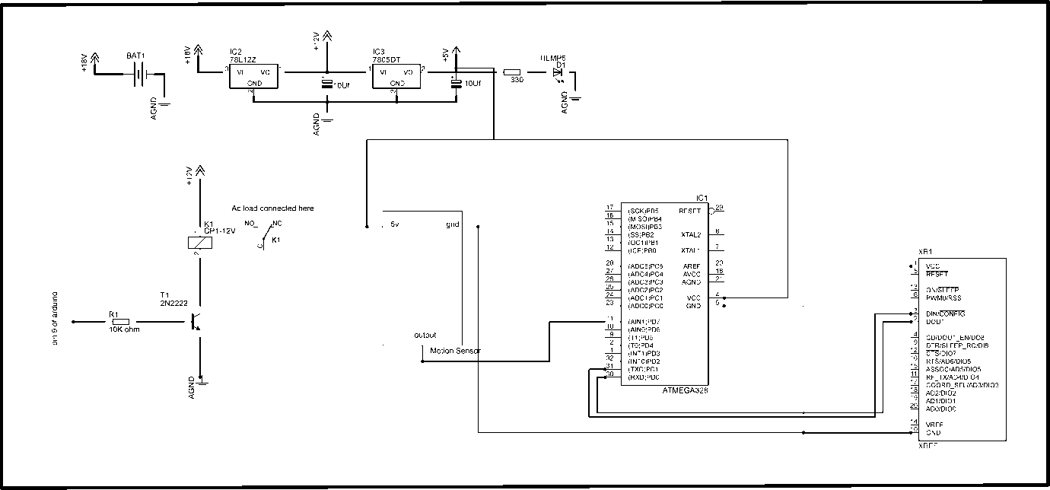When the human is detected it gives a signal to the controller for further processing and decisions. As this section acts as the intermediate so its decision also depends on the first section consisting of the LDR. After processing then the ac load is on with the help of the relay “SPDTA +12Vdc”. This relay is switched on and off with the help of the npn transistor “2n2222”.

Figure 3.3: Schematic Simulation Sketch for Motion sensor

The programming is done in Arduino IDE using c language and the schematics are prepared in the PCB designing software called Cad soft Eagle.

## 3.2 Working Mechanism of ZigBee

When the data from LDR and temperature sensor reaches to the Phase I controller, the ZigBee works and only transmitter. When the controller of Phase I transmits data through ZigBee to the Controller of Phase II, the ZigBee both works and transmitter and receiver also. ZigBee is controlled by pin IDs through X-CTU program. In order to secure the designed network the pin IDs works as a passkeys, so un authorize entry can be prohibited.

# Chapter 4

# TOOLS AND TECHNIQUES

## 4.1Hardware used with technical specifications

### 4.1.1 ZigBee

ZigBee is a mesh network specification for low-power wireless local area networks (WLANs) that cover a large area. The standard was designed to provide high data throughput in applications where the duty cycle is low and low power consumption is an important consideration. ZigBee is a [mesh network](http://searchnetworking.techtarget.com/definition/mesh-network) specification for low-power wireless local area networks ([WLANs](http://searchmobilecomputing.techtarget.com/definition/wireless-LAN)) that cover a large area.

ZigBee was designed to provide high data [throughput](http://searchnetworking.techtarget.com/definition/throughput) in applications where the [duty cycle](http://whatis.techtarget.com/definition/duty-cycle) is low and low power consumption is an important consideration. (Many devices that use ZigBee are powered by battery.) Because ZigBee is often used in industrial automation and physical plant operation, it is often associated with machine-to-machine ([M2M](http://searchnetworking.techtarget.com/definition/M2M)) communication and the Internet of Things ([IoT](http://whatis.techtarget.com/definition/Internet-of-Things)).

ZigBee is based on the Institute of Electrical and Electronics Engineers Standards Association's[802.15](http://searchmobilecomputing.techtarget.com/definition/80215) specification. It operates on the [IEEE](http://whatis.techtarget.com/definition/IEEE-Institute-of-Electrical-and-Electronics-Engineers) 802.15.4 physical radio specification and in unlicensed [radio frequency](http://searchnetworking.techtarget.com/definition/radio-frequency) bands, including 2.4[GHz](http://searchnetworking.techtarget.com/definition/gigahertz), 900 [MHz](http://searchnetworking.techtarget.com/definition/megahertz) and 868 MHz. The specifications are maintained and updated by the ZigBee Alliance.

As of this writing, there are three ZigBee specifications: ZigBee, ZigBee IP and ZigBee RF4CE. ZigBee IP optimizes the standard for [IPv6](http://searchenterprisewan.techtarget.com/definition/IPv6) full mesh networks and ZigBee RF4CE optimizes the standard for partial mesh networks.

ZigBee is the name of a specification for a suite of high level communication protocols using small, low-power, low data rate digital radios based on the IEEE 802.15.4 standard for wireless personal area networks (WPANs), such as wireless headphones connecting with cell phones via short-range radio. The technology is intended to be simpler and cheaper than other WPANs, such as Bluetooth. ZigBee is targeted at radio-frequency (RF) applications which require a low data rate, long battery life, and secure networking.

ZigBee is a low [data](http://www.webopedia.com/TERM/d/data.html) rate, two-way standard for home automation and data [networks](http://www.webopedia.com/TERM/n/network.html). The standard specification for up to 254 [nodes](http://www.webopedia.com/TERM/n/node.html) including one master, managed from a single [remote](http://www.webopedia.com/TERM/r/remote.html) control. Real usage examples of ZigBee includes home automation tasks such as turning lights on, setting the home [security system](http://www.webopedia.com/TERM/Z/ZigBee.html##), or starting the VCR. With ZigBee all these tasks can be done from anywhere in the home at the touch of a button. ZigBee also allows for dial-in access via the [Internet](http://www.webopedia.com/TERM/I/Internet.html) for automation control.

The ZigBee standard uses small very low-power [devices](http://www.webopedia.com/TERM/d/device.html) to connect together to form a [wireless](http://www.webopedia.com/Mobile_Computing/Wirelsess_Computing) control web. A ZigBee network is capable of supporting up to 254 client nodes plus one full functional device (master). ZigBee protocol is optimized for very long battery life measured in months to years from inexpensive, off-the-shelf non-rechargeable batteries, and can control lighting, air conditioning and heating, smoke and fire alarms, and other security devices. The standard supports 2.4 [GHz](http://www.webopedia.com/TERM/G/GHz.html) (worldwide), 868 [MHz](http://www.webopedia.com/TERM/M/MHz.html) (Europe) and 915 MHz (Americas) unlicensed [radio](http://www.webopedia.com/TERM/Z/ZigBee.html##) bands with range up to 75 meters.

#### 4.1.1.1IEEE 802.15.4

ZigBee is a wireless technology developed as an open global standard to address the unique needs of low-cost, low-power wireless M2M networks. The ZigBee standard operates on the IEEE 802.15.4 physical radio specification and operates in unlicensed bands including 2.4 GHz, 900 MHz and 868 MHz.

The 802.15.4 specification upon which the ZigBee stack operates gained ratification by the [Institute of Electrical and Electronics Engineers](http://www.ieee.org/portal/site) (IEEE) in 2003. The specification is a packet-based radio protocol intended for low-cost, battery-operated devices. The protocol allows devices to communicate in a variety of network topologies and can have battery life lasting several years.

IEEE 802.15.4 is a standard which specifies the [physical layer](http://en.wikipedia.org/wiki/Physical_layer) and [medium access control](http://en.wikipedia.org/wiki/Medium_access_control) for low-rate wireless [personal area networks](http://en.wikipedia.org/wiki/Personal_area_network) (LR-WPAN's).This standard was chartered to investigate a low data rate solution with multi-month to multi-year battery life and very low complexity. It is operating in an unlicensed, international frequency band.  Potential applications are sensors, interactive toys, smart badges, remote controls, and home automation.

802.15.4 is part of the 802.15 wireless [personal-area network](http://www.nwfusion.com/links/Encyclopedia/P/468.html) effort at the IEEE. It is a simple packet-based radio protocol aimed at very low-cost, battery-operated widgets and sensors (whose batteries last years, not hours) that can intercommunicate and send low-bandwidth data to a centralized device. It is the basis for the [ZigBee](http://en.wikipedia.org/wiki/ZigBee) specification, which further attempts to offer a complete networking solution by developing the upper [layers](http://en.wikipedia.org/wiki/Protocol_stack) which are not covered by the standard.

* 802.15.4 Protocol.
* Data rates of 250 kbps with 10-100 meter range.
* Two addressing modes; 16-bit short and 64-bit IEEE addressing.
* Support for critical latency devices, such as joysticks.
* CSMA-CA channel access.
* Automatic network establishment by the coordinator.
* Fully handshake protocol for transfer reliability.
* Power management to ensure low power consumption.
* 16 channels in the 2.4GHz ISM band.
* Low duty cycle - Provides long battery life.
* Low latency.
* Support for multiple network topologies: Static, dynamic, star and mesh.
* Direct Sequence Spread Spectrum (DSSS).

Up to 65,000 nodes on a network 128-bit AES encryption – Provides secure connections between devices.

#### 4.1.1.2ZigBee Applications

ZigBee enables broad-based deployment of wireless networks with low-cost, low-power solutions. It provides the ability to run for years on inexpensive batteries for a host of monitoring applications: Lighting controls, AMR (Automatic Meter Reading), smoke and CO detectors, wireless telemetry, HVAC control, heating control, home security, Environmental controls and shade controls, etc.

#### 4.1.1.3The ZigBee Protocol

The ZigBee protocol has been created and ratified by member companies of the [ZigBee Alliance](http://www.zigbee.org/). Over 300 leading semiconductor manufacturers, technology firms, OEMs and service companies comprise the ZigBee Alliance membership. The ZigBee protocol was designed to provide an easy-to-use wireless data solution characterized by secure, reliable wireless network architectures.

#### 4.1.1.4The ZigBee Advantage

The ZigBee protocol is designed to communicate data through hostile RF environments that are common in commercial and industrial applications.

#### 4.1.1.5ZigBee protocol features include

Support for multiple network topologies such as point-to-point, point-to-multipoint and mesh networks.

* Low duty cycle – provides long battery life.
* Low latency.
* Direct Sequence Spread Spectrum (DSSS).
* Up to 65,000 nodes per network.
* 128-bit AES encryption for secure data connections.
* Collision avoidance, retries and acknowledgements.

#### 4.1.1.6Mesh Networks

A key component of the ZigBee protocol is the ability to support mesh networking. In a mesh network, nodes are interconnected with other nodes so that multiple pathways connect each node. Connections between nodes are dynamically updated and optimized through sophisticated, built-in mesh routing table.



Figure 4.1: Mesh network

Mesh networks are decentralized in nature; each node is capable of self-discovery on the network. Also, as nodes leave the network, the mesh topology allows the nodes to reconfigure routing paths based on the new network structure. The characteristics of mesh topology and ad-hoc routing provide greater stability in changing conditions or failure at single nodes.

### 4.1.2 Single Pole Double Throw(SPDT)

The Single Pole Double Throw SPDT relay is quite useful because of its internal configuration. It has one common terminal and 2 contacts in 2 different configurations. One can be Normally Closed and the other one is opened or it can be Normally Open and the other one closed. So basically you can see the SPDT relay as a way of switching between 2 circuits: when there is no voltage applied to the coil one circuit “receives” current, the other one doesn’t and when the coil gets energised the opposite is happening. The relay driver is used to isolate both the controlling and the controlled device. The relay is an electromagnetic device, which consists of solenoid, moving contacts (switch) and restoring spring and consumes comparatively large amount of power. Hence it is possible for the interface IC to drive the relay satisfactorily.

To enable this, the driver circuitry senses the presence of a “high” level at the input and drives the relay from another voltage source. Hence the relay is used to switch the electrical supply to the appliances. When we connect the rated voltage across the coil the back emf opposes the current flow but after the short time the supplied voltage will overcome the back emf and the current flow through the coil increase. When the current is equal to the activating current of relay the core is magnetized and it attracts the moving contacts. Now the moving contact leaves from its initial position denoted “(N/C)” normally closed terminal. The common contact or moving contact establishes the connection with a new terminal which is indicated as a normally open terminal “(N/O)”.

Whenever, the supply coil is withdrawn the magnetizing force is vanished. Now, the spring pulls the moving contact back to initial position, where it makes a connection makes with N/C terminal.

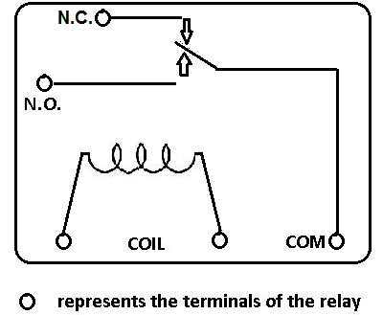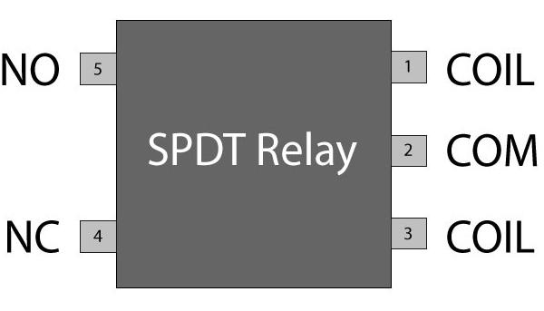However, it is also to be noted that at this time also a back emf is produced. The withdrawal time may be in microsecond, the back emf may be in the range of few kilovolts and in opposite polarity with the supplied terminals the voltage is known as surge voltage. It must be neutralized or else it may damage the system.

Figure 4.2: Single Pole Double Throw (SPDT) Relay

### 4.1.3 Capacitors

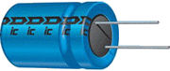The Capacitor, sometimes referred to as a Condenser, is a simple passive device that is used to “store electricity”. The capacitor is a component which has the ability or “capacity” to store energy in the form of an electrical charge producing a potential difference (Static Voltage) across its plates, much like a small rechargeable battery.The Capacitor, sometimes referred to as a Condenser, is a simple passive device that is used to “store electricity”. The capacitor is a component which has the ability or “capacity” to store energy in the form of an electrical charge producing a potential difference (Static Voltage) across its plates, much like a small rechargeable battery. In its basic form, a [Capacitor](http://amazon.com/dp/0962852538/?tag=basicelecttut-20) consists of two or more parallel conductive (metal) plates which are not connected or touching each other, but are electrically separated either by air or by some form of a good insulating material such as waxed paper, mica, ceramic, plastic or some form of a liquid gel as used in electrolytic capacitors. The insulating layer between capacitors plates is commonly called the Dielectric.

Figure 4.3: Capacitor

Due to this insulating layer, DC current cannot flow through the capacitor as it blocks it allowing instead a voltage to be present across the plates in the form of an electrical charge.

The conductive metal plates of a capacitor can be square, circular or rectangular, or they can be of a cylindrical or spherical shape with the general shape, size and construction of a parallel plate capacitor depending on its application and voltage rating.

When used in a direct current or DC circuit, a capacitor charges up to its supply voltage but blocks the flow of current through it because the dielectric of a capacitor is non-conductive and basically an insulator. However, when a capacitor is connected to an alternating current or AC circuit, the flow of the current appears to pass straight through the capacitor with little or no resistance.

There are two types of electrical charge, positive charge in the form of Protons and negative charge in the form of Electrons. When a DC voltage is placed across a capacitor, the positive (+ve) charge quickly accumulates on one plate while a corresponding negative (-ve) charge accumulates on the other plate. For every particle of +ve charge that arrives at one plate a charge of the same sign will depart from the -ve plate.

Then the plates remain charge neutral and a potential difference due to this charge is established between the two plates. Once the capacitor reaches its steady state condition an electrical current is unable to flow through the capacitor itself and around the circuit due to the insulating properties of the dielectric used to separate the plates.

The flow of electrons onto the plates is known as the capacitors Charging Current which continues to flow until the voltage across both plates (and hence the capacitor) is equal to the applied voltage. At this point the capacitor is said to be “fully charged” with electrons. The strength or rate of this charging current is at its maximum value when the plates are fully discharged (initial condition) and slowly reduces in value to zero as the plates charge up to a potential difference across the capacitors plates equal to the source voltage.

The amount of potential difference present across the capacitor depends upon how much charge was deposited onto the plates by the work being done by the source voltage and also by how much capacitance the capacitor has and this is illustrated below.

#### 4.1.3.1 Capacitor Construction

The parallel plate capacitor is the simplest form of capacitor. It can be constructed using two metal or metallised foil plates at a distance parallel to each other, with its capacitance value in Farads, being fixed by the surface area of the conductive plates and the distance of separation between them. Altering any two of these values alters the value of its capacitance and this forms the basis of operation of the variable capacitors.

Also, because capacitors store the energy of the electrons in the form of an electrical charge on the plates the larger the plates and/or smaller their separation the greater will be the charge that the capacitor holds for any given voltage across its plates. In other words, larger plates, smaller distance, more capacitance. By applying a voltage to a capacitor and measuring the charge on the plates, the ratio of the charge Qto the voltage V will give the capacitance value of the capacitor and is therefore given as:

C = Q/V

This equation can also be re-arranged to give the more familiar formula for the quantity of charge on the plates as:

Q = C x V

Although we have said that the charge is stored on the plates of a capacitor, it is more correct to say that the energy within the charge is stored in an “electrostatic field” between the two plates. When an electric current flows into the capacitor, charging it up, the electrostatic field becomes stronger as it stores more energy. Likewise, as the current flows out of the capacitor, discharging it, the potential difference between the two plate’s decreases and the electrostatic field decreases as the energy moves out of the plates. The property of a capacitor to store charge on its plates in the form of an electrostatic field is called the Capacitance of the capacitor. Not only that, but capacitance is also the property of a capacitor which resists the change of voltage across it.

#### 4.1.3.2 Voltage Rating of a Capacitor

All capacitors have a maximum voltage rating and when selecting a capacitor consideration must be given to the amount of voltage to be applied across the capacitor. The maximum amount of voltage that can be applied to the capacitor without damage to its dielectric material is generally given in the data sheets as: WV, (working voltage) or as WV DC, (DC working voltage).

If the voltage applied across the capacitor becomes too great, the dielectric will break down (known as electrical breakdown) and arcing will occur between the capacitor plates resulting in short-circuit. The working voltage of the capacitor depends on the type of dielectric material being used and its thickness.

* Surface Area – the surface area, A of the two conductive plates which make up the capacitor, the larger the area the greater the capacitance.
* Distance – the distance, d between the two plates, the smaller the distance the greater the capacitance.
* Dielectric Material – the type of material which separates the two plates called the “dielectric”,

We have also seen that a capacitor consists of metal plates that do not touch each other but are separated by a material called a dielectric. The dielectric of a capacitor can be air, or even a vacuum but is generally a non-conducting insulating material, such as waxed paper, glass, mica different types of plastics etc. The dielectric provides the following advantages:

* The dielectric constant is the property of the dielectric material and varies from one material to another increasing the capacitance by a factor of k.
* The dielectric provides mechanical support between the two plates allowing the plates to be closer together without touching.
* Permittivity of the dielectric increases the capacitance.
* The dielectric increases the maximum operating voltage compared to air.

### 4.1.4Arduino Uno

The Arduino Uno is a microcontroller board based on the ATmega328. It has 14 digital input/output pins (of which 6 can be used as PWM outputs),6 analog inputs, a 16MHz crystal oscillator, a USB connection, a power jack, an ICSP header, and a reset button. It contains everything needed to support the microcontroller; simply connect it to a computer with a USB cable or power it with a AC-to-DC adapter or battery to get started. The Uno differs from all preceding boards in that it does not use the FTDI USB-to-serial driver chip. Instead, it features the Atmega8U2 programmed as a USB-to-serial converter.

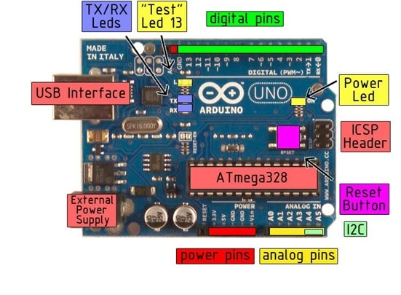Figure 4.4: Arduino Uno

"Uno" means one in Italian and is named to mark the upcoming release of Arduino 1.0. The Uno and version 1.0 will be the reference versions of Arduno, moving forward. The Uno is the latest in a series of USB Arduino boards, and the reference model for the Arduino platform.

|  |  |
| --- | --- |
| **MICROCONTROLLER** | **ATMEGA328** |
| Operating Voltage | 5V |
| Input Voltage (recommended | 7-12V |
| Input Voltage (limits) | 6-20V |
| Digital I/O Pins | 14 (of which 6 provide PWM output) |
| Analog Input Pins | 6 |
| DC Current per I/O Pin | 40 mA |
| DC Current for 3.3V Pin | 50 mA |
| Flash Memory | 32 KB ofwhich0.5 KB used by bootloader |
|  | 2 KB |
| EEPROM | 1 KB |
| Clock Speed |  |

Table 4.1: Arduino Uno Specifications

The power pins are as follows:

* VIN. The input voltage to the Arduino board when it's using an external power source (as opposed to 5 volts from the USB connection or other regulated power source). You can supply voltage through this pin, or, if supplying voltage via the power jack, access it through this pin.
* 5V.Theregulated power supply used to power the microcontroller and other components on the board. This can come either from VIN via an on-board regulator, or be supplied by USB or another regulated 5V supply.
* 3V3. A 3.3 volt supply generated by the on-board regulator. Maximum current draw is 50 mA.
* GND. Ground pins.
* Serial: 0 (RX) and 1 (TX). Used to receive (RX) and transmit (TX) TTL serial data. These pins are connected to the corresponding pins of the ATmega8U2 USB-to-TTL Serial chip.
* External Interrupts: 2 and 3. These pins can be configured to trigger an interrupt on a low value, a rising or falling edge, or a change in value. See the [attach Interrupt()](http://arduino.cc/en/Reference/AttachInterrupt) function for details.
* PWM: 3, 5, 6, 9, 10, and 11. Provide 8-bit PWM output with the [analog Write()](http://arduino.cc/en/Reference/AnalogWrite) function.
* SPI: 10 (SS), 11 (MOSI), 12 (MISO), 13 (SCK). These pins support SPI communication, which, although provided by the underlying hardware, is not currently included in the Arduino language.
* LED: 13. There is a built-in LED connected to digital pin 13. When the pin is HIGH value, the LED is on, when the pin is LOW, it's off.

#### 4.1.4.1 ATmega328

The ATmega328 is a low-power CMOS 8-bit microcontroller based on the AVR enhanced RISC architecture. By executing powerful instructions in a single clock cycle, the ATmega328 achieves throughputs approaching 1 MIPS per MHz allowing the system designed to optimize power consumption versus processing speed. The ATmega328 provides the following features: 4K/8Kbytes of In-System programmable Flash with Read-While-Write capabilities, 1Kbytes EEPROM,2Kbytes SRAM, 23 general purpose I/O lines, 32 general purpose working registers, three flexible Timer/Counters with compare modes, internal and external interrupts, a serial programmable USART, a byte-oriented 2-wire Serial Interface, an SPI serial port, a 6-channel 10-bit ADC (8 channels in TQFP and QFN/MLF packages), a programmable Watchdog Timer with internal Oscillator, and five software selectable power saving modes. The Idle mode stops the CPU while allowing the SRAM, Timer/Counters, USART, 2-wire Serial Interface, SPI port, and interrupt system to continue functioning. The Power-down mode saves the register contents but freezes the Oscillator, disabling all other chip functions until the next interrupt or hardware reset. In Power-save mode, the asynchronous timer continues to run, allowing the user to maintain a timer base while the rest of the device is sleeping. The ADC Noise Reduction mode stops the CPU and all I/O modules except asynchronous timer and ADC, to minimize switching noise during ADC conversions. In Standby mode, the crystal/resonator Oscillator is running while the rest of the device is sleeping. This allows very fast start-up combined with low power consumption.

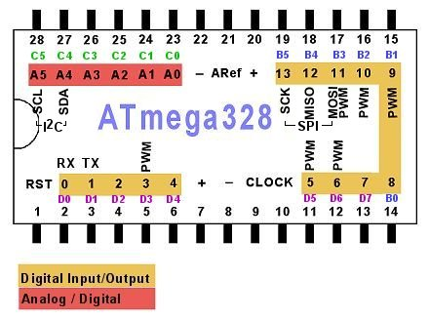

Figure 4.5: ATmega 328

|  |  |
| --- | --- |
| **Parameters** | **Value** |
| Flash | 32 Kbytes |
| RAM | 2 Kbytes |
| Pin Count | 28 |
| Max. Operating Frequency | 20 MHz |
| CPU | 8-bit AVR |
| # of Touch Channels | 16 |
| Hardware QTouch Acquisition | No |
| Max I/O Pins | 26 |
| Ext Interrupts | 24 |
| USB Interface | No |

Table 4.2: ATmega328 Specifications

### 4.1.5 7805 IC

Voltage Regulator is one of the most important and commonly used electrical components. Voltage Regulators are responsible for maintaining a steady voltage across an Electronic system. Voltage fluctuations may result in undesirable effect on an electronic system, so to maintaining a steady constant voltage is necessary according to the voltage requirement of a system.

The 7805 IC is three terminal positive voltage regulators is available with fixed output voltages making them useful in a wide range of applications. This regulator is in expensive, vies-to-use devices suitable for a multitude of applications that require a regulated supply of up to 800 mA. It includes feature of internal current limiting and thermal shutdown making them remarkably rugged. No external components are required with the 7805 devices in many applications. These devices offer a substantial performance advantage over the traditional zener diode-resistor combination, as output impedance and quiescent current are substantially reduced. The 7805 is available in 3-Pin plastic package SOT54 (Z), offers superior quality and performance at low cost.

IC 7805 is a 5V Voltage Regulator that restricts the voltage output to 5V and draws 5V regulated power supply. It comes with provision to add heat-sink.

The maximum value for input to the voltage regulator is 35V. It can provide a constant steady voltage flow of 5V for higher voltage input till the threshold limit of 35V. If the voltage is near to 7.5V then it does not produce any heat and hence no need for heat sink. If the voltage input is more, then excess electricity is liberated as heat from 7805.

It regulates a steady output of 5V if the input voltage is in rage of 7.2V to 35V. Hence to avoid power loss try to maintain the input to 7.2V. In some circuitry voltage fluctuation is fatal (for e.g. Microcontroller), for such situation to ensure constant voltage IC 7805 Voltage Regulators used. For more information on specifications of 7805 Voltage Regulator please refer the data sheet here (IC 7805 Voltage Regulator Data Sheet). IC 7805 is a series of 78XX voltage regulators. It’s a standard, from the name the last two digits 05 denotes the amount of voltage that it regulates. Hence a 7805 would regulate 5v and 7806 would regulate 6V and so on.

#### 4.1.5.1 Features of 7805 IC

* High Output Current.

IO= 100 mA.

* Fixed Output Voltage.

VO= 5 V.

* Available in either ±5% (AC) Selection.

[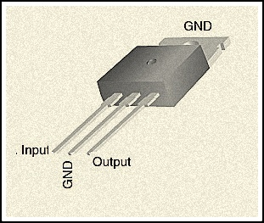](http://www.electronicshub.org/wp-content/uploads/2013/12/Pin-diagram-of-IC-7805.jpg)

Figure 4.6: 7805 IC

The pin explanation of the 7805 is described in the following table:

|  |  |  |  |
| --- | --- | --- | --- |
| **Pin No** | **Function** | **Name** | **DESCRIPTION** |
| 1 | Input voltage (5V-18V) | Input | In this pin of the IC positive unregulated voltage is given in regulation. |
| 2 | Ground (0V) | Ground | In this pin where the ground is given. This pin is neutral for equally the input and output. |
| 3 | Regulated output; 5V (4.8V-5.2V) | Output | The output of the regulated 5V volt is taken out at this pin of the IC regulator. |

Table 4.3: 7805 IC Specifications

The schematic given below shows how to use a 7805 IC, there are 3 pins in IC 7805, and pin 1 takes the input voltage and pin 3 produces the output voltage. The GND of both input and out are given to pin 2.

#### 4.1.5.2 Pin Description

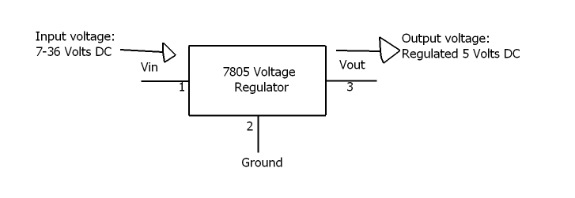

Figure 4.7: Pin Description of 7805 IC

#### 4.1.5.3 7805 IC working

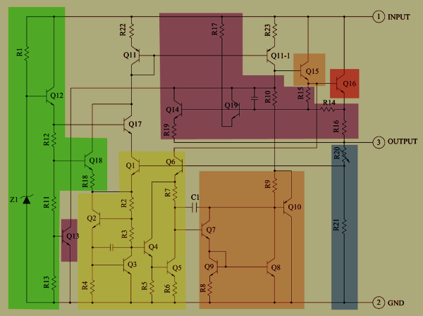We have colour the following schematic to indicate the main blocks of the 7805 regulator. The heart of the 7805 chip is a large transistor that controls the current between the input and output, and thus controls the output voltage. This transistor (Q16) is red on the diagram below. On the die, it takes up most of the right half of the chip because it needs to handle over 1 amp of current.

Figure 4.8: 7805 IC working

The main problem with producing a stable voltage from an IC is the chip's parameters change as temperature changes: it's no good if we have 5 volt phone charger starts producing 3 or 7 volts on a hot day. The trick to building a stable voltage reference is to create one voltage that goes down with temperature and another than goes up with temperature. If you add them together correctly, but get a voltage that is stable with temperature. This circuit is called a "band-gap reference".

To create a voltage that goes down with temperature, we have put a constant current through the transistor and look at the voltage between the base and emitter, called VBE. The graph below shows how this voltage drops as the temperature increases. At the left, the line hits the band-gap voltage of silicon, about 1.2 volts; this will be important later.

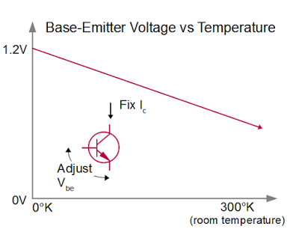

Figure 4.9: Base Emitting Voltage via Temperature

### 4.1.6 78L12z IC

A 7812 is a linear regulator, and does not step up the input voltage if the input is below the output (for that you need a DC-DC boost regulator). The input voltage must be above the output. All linear regulators have a minimum dropout voltage, or difference.

This 7812 is fixed-voltage integrated-circuit voltage regulators is designed for a wide range of applications. These applications include on-card regulation for elimination of noise and distribution problems associated with single-point regulation. In addition, they can be used with power-pass elements to make high-current voltage regulators. It can deliver up to 100 mA of output current. The internal limiting and thermal-shutdown features of these regulators make them essentially immune to overload. When used as a replacement for a zener diode-resistor combination, an effective improvement in output impedance can be obtained, together with lower bias current.7812 is a famous IC which is being widely used in 12V voltage regulator circuits. Truly speaking it is a complete standalone voltage regulator. We only need to use two capacitors, one on the input and second one on the output of 7812 in order to achieve clean voltage output and even these capacitors are optional to use. To achieve 12V 1A current, 7812 should be mounted on a good heat-sink plate. Thanks to the transistor like shape of 7812 which makes it easy to mount on a heat-sink plate. 7812 has built in over heat and short circuit protection which makes it a good choice for making power supplies. If we hold the IC upside down (pins up) and the IC number is facing you then the left pin will be the voltage regulator output, the center pin will be ground and the right pin will be the voltage input pin. Under my experience, the maximum safe current you can get from one 7812 IC is 1A.

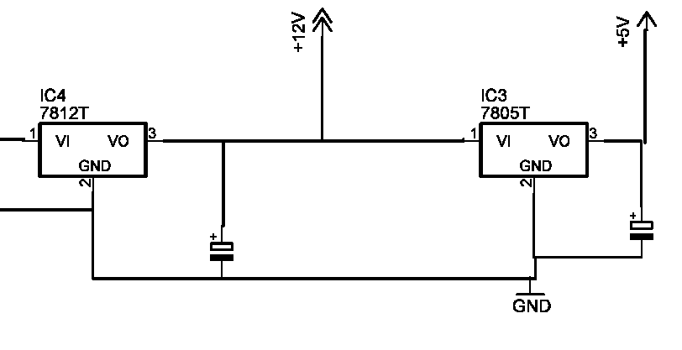The 7812 is not a LDO (low-dropout regulator), as the typical dropout voltage is around 2 volts. (An LDO might have a dropout voltage of 0.7 volts). If we need more power then there are more ways to do so. More than one 7812 can be used in parallel in order to achieve more than 1A current but output voltage of each 7812 can slightly vary resulting in unbalanced load on all of them. This can result in load balancing issues and can damage the IC carrying most current.

Figure 4.10: Circuit Diagram of 78L12z IC

### 4.1.7 2n222 Transistor

The 2N2222 is a common [NPN](https://en.wikipedia.org/wiki/NPN_transistor) [bipolar junction transistor](https://en.wikipedia.org/wiki/Bipolar_junction_transistor) (BJT) used for general purpose low power [amplifying](https://en.wikipedia.org/wiki/Amplifier) or switching applications. It is designed for low to medium [current](https://en.wikipedia.org/wiki/Electric_current), low [power](https://en.wikipedia.org/wiki/Electric_power), medium [voltage](https://en.wikipedia.org/wiki/Voltage), and can operate at moderately high speeds. The 2N2222 is considered a very common transistor, and is used as an exemplar of an NPN transistor. It is frequently used as a small-signal transistor, and it remains a small general purpose transistor of endure. The 2N222 [transistor](http://www.wisegeek.com/what-is-a-transistor.htm) is a common negative-positive-negative (NPN) bipolar junction transistor (BJT) that finds use in many different kinds of electronic equipment. It is used for both analog signal amplification and switching applications. The functioning parts of the 2N2222 transistor are enclosed in what is known as a TO-18 package, which resembles a small metal can. The broad range of uses for the 2N2222 transistor, and its small size, make it the most widely used transistors in electronics.

The functioning portion of the 2N2222 transistor is a NPN BJT construct. The 2N2222 transistor is made of either [germanium](http://www.wisegeek.com/what-is-germanium.htm) or silicon that has been saturated with either a positively or negatively changed material in a process called “doping.” The 2N2222 has a positively charged section sandwiched between two negatively charged sections. The resulting two connections between the three sections are where the 2N2222 derives the name “bipolar junction transistor.” The materials used are arranged in the order of negative, positive, then negative, so the device is also said to be a [NPN transistor](http://www.wisegeek.com/what-is-an-npn-transistor.htm).

The 2N2222 has three wire leads used to solder it to circuit boards: the collector, the [emitter](http://www.wisegeek.com/what-is-an-emitter.htm), and the base. When an electronic signal is present at the transistor’s collector, applying a signal to the transistor’s base will cause a signal to emit from the device’s emitter. In this way, the 2N2222 is often used to switch signals on and off.

#### 4.1.7.1 Switching

The switching abilities of the 2N2222 transistor also make it useful as a simple “and” gate. When used in this capacity, the transistor will only send a signal when two separate signals are present: one at its collector and one at its base. This allows the 2N2222 to be used to automatically control signal flow in a circuit depending on what signals are, or are not, present.

#### 4.1.7.2 Amplification

In amplification applications, the 2N2222 receives an analog signal, such as an audio signal, through its collector and a separate signal is applied to its base. The output at the transistor’s emitter will then be identical to the collector signal with the exception that it increases in power by an amount proportional to the signal applied to its base. Additionally, varying the signal applied to the base will vary the amplification of the signal leaving the emitter.

#### 4.1.7.3 Operational characteristics

Operational characteristics make the 2N2222 a low- to medium-current (up to 600 milliamps), low-power (up to 625 milliwatts), medium-voltage (up to 40 volts) device. Though these parameters may seem to limit the 2N2222’s usefulness, the 2N2222 is perfect for a host of signal manipulation and handling applications prior to high-power amplification. 2N2222 transistors are also used to condition signals before and after application to more advanced digital devices.

While the 2N2222 was the first of its kind, it has spawned a number of variants collectively called “2N2222 type” transistors, because they all share functional-construction and operational characteristics identical to the original 2N2222 transistor. Chief among these variants is the P2N2222 transistor, which is enclosed in a small black TO-92 package made of either epoxy or plastic. The combination of the large number of uses for the 2N2222 and the cost-effective TO-92 package has made the P2N2222 the least expensive and most used transistor in electronics.

The transistor 2N2222 is one of the important and very commonly used transistor type which finds numerous switching application in electronic circuits.

#### 4.1.7.4 Features

The main feature of this transistor is its ability to handle relatively high magnitudes of currents compared to other similar small signal types of transistors. Typically, a 2N2222 transistor is able to switch 800 mA of load current through it, which may be considered quite high compared to the miniature size owned by these devices. High current switching capability also makes this device ideally suited for linear amplifier applications.

#### 4.1.7.5 Characteristics

The main characteristics of this device may be understood with the following points:

* The transistor 2N2222 or 2N2222A are NPN types and has the following electrical parameters:
* The device’s maximum voltage tolerance (breakdown voltage) across its collector and base is 60 volts for 2N2222 and 75 volts for 2N2222A, with the emitters kept open.
* With their base open, the above tolerance across their collector and emitter leads is 30 volts for 2N2222 and 40 volts for 2N2222A.
* As expressed earlier, the maximum current that can be applied across the transistors collector and emitter, via a load is not more than 800 mA.
* Total power dissipation of the device should not exceed above 500 mW.
* HFE or the DC current gain of 2N2222 transistors will be around 75 minimum, at voltages near 10, with 10 mA collector current.
* Maximum frequency handling capacity or the transition frequency is 250 MHz for 2N2222 and 300 MHz for 2N2222A.

 The base-emitter saturation voltage for 2N2222 is typically 1.3 volts @ 15 mA, when the collector current is around 150 mA. With collector current exceeding 500 mA, the base optimal trigger voltage becomes 2.6 volts. For a 2N2222A, the figures are 1.2 and 2 volts respectively. Configuring the device practically in electronic circuits for any relevant application:

This may be done by following the below explained steps:

* The pin out or the leg that’s marked emitter must be connected to the negative line of the supply rail.
* The load which needs to be switched must be connected in between the collector of the transistor and the positive supply, that is, the positive lead of the load goes to the positive supply while the other lead of the load gets connected to the collector lead of the transistor.
* The base goes to the source voltage or the triggering voltage via a current limiting resistor.
* The value of the current limiting resistor may be calculated by using the formula explained at the end of [this article.](http://homemadecircuitsandschematics.blogspot.in/2012/01/how-to-make-relay-driver-stage-in.html)
* The transistor 2N2907 is complementary pair for 2N2222 and has identical specs as above, however being a PNP type the associated polarities are exactly opposite

#### 4.1.7.6 Specifications

The [JEDEC](https://en.wikipedia.org/wiki/JEDEC) registration of a device number ensures particular rated values will be met by all parts offered under that number. JEDEC registered parameters include outline dimensions, small-signal current [gain](https://en.wikipedia.org/wiki/Gain), [transition frequency](https://en.wikipedia.org/wiki/Gain%E2%80%93bandwidth_product#Transistors), maximum values for voltage withstand, current rating, power dissipation and temperature rating, and others, measured under standard test conditions. Other part numbers will have different parameters. The exact specifications depend on the manufacturer, case type, and variation. Therefore it is important to refer to the datasheet for the exact part number and manufacturer.

|  |  |  |  |  |
| --- | --- | --- | --- | --- |
| **Manufacturer** | **VCE** | **Collector current** | **PD** | **FT** |
| ST Microelectronics[[12]](https://en.wikipedia.org/wiki/2N2222#cite_note-12) 2N2222A | 40V | 800mA | 50mW/1.8W | 300MHz |

Table 4.4: Specifications 2n222 transistor

All variations have a [beta](https://en.wikipedia.org/wiki/Bipolar_junction_transistor#Transistor_.27alpha.27_and_.27beta.27) or current gain (HFE) of at least 100 in optimal conditions. It is used in a variety of analog amplification and switching applications.

### 4.1.8 Resistor

Resistors are electronic components which have a specific, never-changing [electrical resistance](https://learn.sparkfun.com/voltage-current-resistance-and-ohms-law/resistance). The resistor’s resistance limits the flow of electrons through a circuit. They are passive components, meaning they only consume power (and can’t generate it). Resistors are usually added to circuits where they complement active components like op-amps, microcontrollers, and other [integrated circuits](https://learn.sparkfun.com/tutorials/integrated-circuits). Commonly resistors are used to limit current, [divide voltages](https://learn.sparkfun.com/tutorials/voltage-dividers), and [pull-up I/O lines](https://learn.sparkfun.com/tutorials/pull-up-resistors).

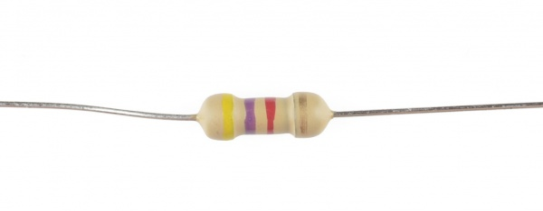

Figure 4.11: Resistor

Resistors can be fabricated in a variety of ways. The most common type in electronic devices and systems is the carbon-composition resistor. Fine granulated carbon (graphite) is mixed with clay and hardened. The resistance depends on the proportion of carbon to clay; the higher this ratio, the lower the resistance.

#### 4.1.8.1 Dimensions and material affects

The resistance R in ohms (Ω) of a resistor is equal to the resistivity ρ in ohm-meters (Ω∙m) times the resistor's length l in meters (m) divided by the resistors cross sectional area A in square meters (m2):

R=\rho \times \frac{l}{A}

#### 4.1.8.2 Resistor colour code

The resistance of the resistor and its tolerance are marked on the resistor with color code bands that denotes the resistance value.

There are 3 types of colour codes:

4 bands: digit, digit, multiplier, tolerance.

5 bands: digit, digit, digit, multiplier, tolerance.

6 bands: digit, digit, digit, multiplier, tolerance, temperature coefficient.

#### 4.1.8.3 Pull-up resistor

In digital circuits, pull-up resistor is a regular resistor that is connected to the high voltage supply (e.g. +5V or +12V) and sets the input or output level of a device to '1'.

The pull-up resistor set the level to '1' when the input / output is disconnected. When the input / output is connected, the level is determined by the device and overrides the pull-up resistor.

#### 4.1.8.4 Pull-down resistor

In digital circuits, pull-down resistor is a regular resistor that is connected to the ground (0V) and sets the input or output level of a device to ' 0 '.

The pull-down resistor set the level to ' 0 ' when the input / output is disconnected. When the input / output is connected, the level is determined by the device and overrides the pull-down resistor.

### 4.1.9 Led

LEDs are tiny lamps, but the way in which they generate light (their principle of operation) is very different from that of incandescent or discharge lamps. LEDs can be seen everywhere these days from digital clocks and remote controls, to all sorts of electronic devices including large display screens and desktop VDUs. LED is an acronym for Light Emitting Diodes. Light as we understand is a form of energy that is visible to our eyes, and diodes are devices made up of a semiconductor material. So in essence, an LED is a device (made up of semiconductor material) that emits light.

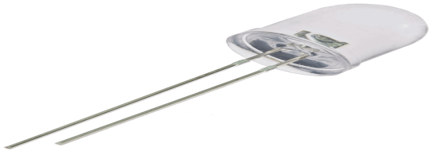

Figure 4.12: Light emitting diode

### 4.1.10 LDR

A light dependent [resistor](http://www.electrical4u.com/types-of-resistor-carbon-composition-and-wire-wound-resistor/) works on the principle of photo conductivity. Photo conductivity is an optical phenomenon in which the materials conductivity (Hence resistivity) reduces when light is absorbed by the material the resistance of the LDR will change when the light will be fall on the LDR. When light falls i.e. when the photons fall on the device which is obtain from the light, the electrons in the valence band of the [semiconductor](http://www.electrical4u.com/theory-of-semiconductor/) material are excited to the conduction band. These photons in the light which fall on the LDR should have energy greater than the band gap of the [semiconductor](http://www.electrical4u.com/theory-of-semiconductor/) material to make the electrons jump from the outer most band to the conduction band. Hence when light having greater energy is fall on the device more & more electrons are jumps from the valance band to the conduction band this process continues until the light is falling on the LDR which results in large number of charge carriers. The result of this process is more and more [current](http://www.electrical4u.com/electric-current-and-theory-of-electricity/) starts flowing which depends on the amount of light that are incident on the LDR if light is more the resistance will be minimum and vice versa.

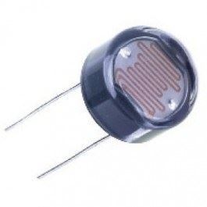

Figure 4.13: Light dependent [resistor](http://www.electrical4u.com/types-of-resistor-carbon-composition-and-wire-wound-resistor/)

#### 4.1.10.1 Characteristics of LDR

LDR’s are light dependent devices whose [resistance](http://www.electrical4u.com/electrical-resistance-and-laws-of-resistance/) minimum when light incident on them and resistance increase when light are not falling on the LDR. When a light dependent [resistor](http://www.electrical4u.com/types-of-resistor-carbon-composition-and-wire-wound-resistor/) is kept in dark, its resistance is very high. This resistance is called as dark [resistance](http://www.electrical4u.com/electrical-resistance-and-laws-of-resistance/). It can be maximum about 1KΩ. And if the device is allowed to absorb light its [resistance](http://www.electrical4u.com/electrical-resistance-and-laws-of-resistance/) will decrease. If a fixed voltage source is applied to it and intensity of light falling is increased the [current](http://www.electrical4u.com/electric-current-and-theory-of-electricity/) starts increasing. Figure below shows [resistance](http://www.electrical4u.com/electrical-resistance-and-laws-of-resistance/) vs. illumination curve for a particular LDR. We can easily find the resistance of LDR when light falling on it.

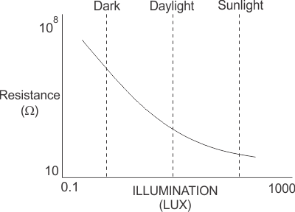

Figure 4.14: Graphical Output of LDR

LDR’s are non-linear devices because its curve decreases or increases in non-linear pattern because when we increase the intensity of light its resistance decrease and its resistance increase when light intensity increases. There sensitivity varies with the wavelength of light incident on them the wave length can be found by using the formula:

**C=λf**

Where c is speed of light, v is velocity and f is the frequency. Some Phototransistor might not at all response to a certain range of wavelengths. Based on the material used different cells have different spectral response curves.

When light is incident on a photocell it usually takes about 8 to 12ms for the change in [resistance](http://www.electrical4u.com/electrical-resistance-and-laws-of-resistance/) to take place, while it takes seconds for the [resistance](http://www.electrical4u.com/electrical-resistance-and-laws-of-resistance/) to rise back again to its initial value after removal of light. This phenomenon is called as [resistance](http://www.electrical4u.com/electrical-resistance-and-laws-of-resistance/) recovery rate. This property is used in audio compressors. Also, LDR’s are less sensitive than photo diodes and photo transistor. (A photo [diode](http://www.electrical4u.com/diode-working-principle-and-types-of-diode/) and a photocell (LDR) are not the same, a photo-diode is a p-n junction [semiconductor](http://www.electrical4u.com/theory-of-semiconductor/) device that converts light to electricity, whereas a photocell is a passive device, there is no p-n junction in this nor it “converts” light to electricity).

#### 4.10.1.2 Types of Light Dependent Resistors

Based on the materials used they are classified as: i) intrinsic photo [resistor](http://www.electrical4u.com/types-of-resistor-carbon-composition-and-wire-wound-resistor/)s (Un- doped semiconductor): These are pure [semiconductor](http://www.electrical4u.com/theory-of-semiconductor/) materials such as silicon or germanium. Electrons get excited from valance band to conduction band when photons of enough energy falls on it and number charge carriers increases.

ii) Extrinsic photo [resistor](http://www.electrical4u.com/types-of-resistor-carbon-composition-and-wire-wound-resistor/)s: These are [semiconductor](http://www.electrical4u.com/theory-of-semiconductor/) materials doped with impurities which are called as dopants. Theses dopants create new energy bands above the valence band which are filled with electrons. Hence this reduces the band gap and less energy is required in exciting them. Extrinsic photo [resistor](http://www.electrical4u.com/types-of-resistor-carbon-composition-and-wire-wound-resistor/)s are generally used for long wavelengths.

### 4.1.11 Motion Sensor PIR

The "motion sensing" feature on most lights (and security systems) is a **passive** system that detects **infrared energy**. These sensors are therefore known as **PIR** (passive infrared) detectors or **pyroelectric** sensors. In order to make a sensor that can detect a human being, we need to make the sensor sensitive to the temperature of a human body. Humans, having a skin temperature of about 93 degrees F, radiate [infrared energy](http://electronics.howstuffworks.com/gadgets/high-tech-gadgets/nightvision1.htm) with a wavelength between 9 and 10 micrometres. Therefore, the sensors are typically sensitive in the range of 8 to 12 micrometres.

#### 4.1.11.1 Overview

PIR sensors allow you to sense motion, almost always used to detect whether a human has moved in or out of the sensors range. They are small, inexpensive, low-power, easy to use and don't wear out. For that reason they are commonly found in appliances and gadgets used in homes or businesses. They are often referred to as PIR, "Passive Infrared", "Pyro electric", or "IR motion" sensors.

PIRs are basically made of a [pyroelectric sensor](http://en.wikipedia.org/wiki/Pyroelectric) (which you can see above as the round metal can with a rectangular crystal in the centre), which can detect levels of infrared radiation. Everything emits some low level radiation, and the hotter something is, the more radiation is emitted. The sensor in a motion detector is actually split in two halves. The reason for that is that we are looking to detect motion (change) not average IR levels. The two halves are wired up so that they cancel each other out. If one half sees more or less IR radiation than the other, the output will swing high or low.

#### 4.1.11.2 Description

PIR sensors are used to detect motion from pets/humanoids from about 20 feet away (possibly works on zombies, not guaranteed). This one has an adjustable delay before firing (approx. 2-4 seconds), adjustable sensitivity and we include a 1 foot (30 cm) cable with a socket so you can easily reposition the sensor or mount it using the two drills on either side

Runs on 5V-16V power (if you need to run it off of 3V you can do that by bypassing the regulator, but that means doing a bit of soldering). Digital signal output is 3.3V high/low. Sensing range is about 7 meters (120 degree cone)

#### 4.1.11.3 Technical Details

Length: 24.03mm/0.94in

Width: 32.34mm/1.27in

Screw hole distance: 28mm

Screw hole diameter: 2mm

Height (with lens): 24.66mm/0.97in

Weight: 5.87g/0.2oz

T­here are many different ways to create a motion sensor. For example:

It is common for stores to have a beam of light crossing the room near the door, and a photo sensor on the other side of the ­room. When a customer breaks the beam, the photo sensor detects the change in the amount of light and rings a bell. Many grocery stores have automatic door openers that use a very simple form of [radar](http://science.howstuffworks.com/radar.htm) to detect when someone passes near the door. The box above the door sends out a burst of microwave [radio](http://electronics.howstuffworks.com/radio.htm) energy and waits for the reflected energy to bounce back. When a person moves into the field of microwave energy, it changes the amount of reflected energy or the time it takes for the reflection to arrive, and the box opens the door. Since these devices use radar, they often set off [radar detectors](http://auto.howstuffworks.com/radar-detector.htm).

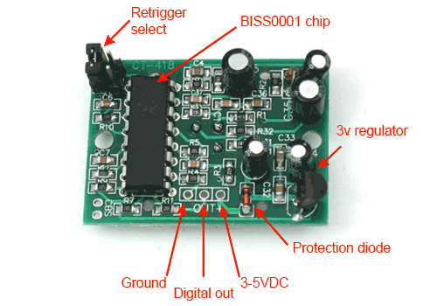

Figure 4.15: Motion Sensor PIR

#### 4.1.11.4 Working of motion Sensors

The same thing can be done with ultrasonic sound waves; bouncing them off a target and waiting for the echo. All of these are active sensors. They inject energy (light, microwaves or sound) into the environment in order to detect a change of some sort. The devices themselves are simple electronic components not unlike a photo sensor. The infrared light bumps electrons off a substrate, and these electrons can be detected and amplified into a signal.

We have probably noticed that light is sensitive to motion, but not to a person who is standing still. That's because the electronics package attached to the sensor is looking for a fairly rapid change in the amount of infrared energy it is seeing. When a person walks by, the amount of infrared energy in the field of view changes rapidly and is easily detected. You do not want the sensor detecting slower changes, like the sidewalk cooling off at night.

Your motion sensing light has a wide field of view because of the lens covering the sensor. Infrared energy is a form of light, so you can focus and bend it with plastic lenses. But it's not like there is a 2-D array of sensors in there. There is a single (or sometimes two) sensors inside looking for changes in infrared energy.

­If we have a burglar alarm with motion sensors, we may have noticed that the motion sensors cannot "see" us when we are outside looking through a window. That is because glass is not very transparent to infrared energy. This, by the way, is the basis of a greenhouse. Light passes through the glass into the greenhouse and heats things up inside the greenhouse. The glass is then opaque to the infrared energy these heated things are emitting, so the heat is trapped inside the greenhouse. It makes sense that a motion detector sensitive to infrared energy cannot see through glass windows.

The Smart Sense Motion sensor lets you know when movement is detected in a certain area of your home and can trigger different actions in response to that movement. Set lights to turn on and off as you come and go; and protect your home by triggering lights, sirens, and other electronics to turn on if there’s unexpected motion in your home. The sensor can also detect temperature and trigger smart thermostats, window A/C units, or portable heaters to automatically adjust as people come and go. Place the motion sensor on a table or shelf, or use the included mounting plate and screws to place it on a wall.

#### 4.1.11.5 Uses

* Trigger lights to automatically turn on when you enter a room.
* Receive an immediate alert if unexpected motion is detected while you’re away or asleep.
* Save energy by turning off lights and electronics in areas that aren’t being used.
* Set up a flood light to turn on when your car enters the driveway.
* Automatically turn on a night-light when your child gets out of bed.
* Know the temperature in any area of your home in Celsius or Fahrenheit.
* Trigger your smart thermostat, A/C unit, or portable heater to automatically adjust when people come and go.

#### 4.1.11.6 Dimensions

* Communication protocol: ZigBee.
* Dimensions: 2.6 x 2.6 x 1.1".
* Weight: 3.4 ounces (with battery).
* Battery: 1 CR123 battery included.
* Mounting plate dimensions: 2.3 x 2.3 x 0.32".
* Range: 50+ feet (depending on your home’s construction and whether or not you have ZigBee repeaters).

#### 4.1.11.7 Some Basic Stats

These stats are for the PIR sensor in the shop which is very much [like the Parallax one](http://www.parallax.com/Store/Sensors/ObjectDetection/tabid/176/ProductID/83/List/0/Default.aspx?SortField=ProductName,ProductName). Nearly all PIRs will have slightly different specifications, although they all pretty much work the same. If there's a datasheet, you'll want to refer to it.

Size: Rectangular

Output: Digital pulse high (3V) when triggered (motion detected) digital low when idle (no motion detected). Pulse lengths are determined by resistors and capacitors on the PCB and differ from sensor to sensor.

Sensitivity range: up to 20 feet (6 meters) 110° x 70° detection range

Power supply: 3V-9V input voltage, but 5V is ideal.

### 4.1.12 Temperature Sensor LM35

The LM35 series are precision integrated-circuit temperature devices with an output voltage linearly-proportional to the Centigrade temperature. The sensor circuitry is sealed and therefore it is not subjected to oxidation and other processes. With**LM35,** temperature can be measured more accurately than with a thermistor. It also possesses low self-heating and does not cause more than 0.1oC temperature rise in still air. The LM35 device has an advantage over linear temperature sensors calibrated in Kelvin, as the user is not required to subtract a large constant voltage from the output to obtain convenient Centigrade scaling. The LM35 device does not require any external calibration or trimming to provide typical accuracies of ±¼°C at room temperature and ±¾°C over a full −55°C to 150°C temperature range. Lower cost is assured by trimming and calibration at the wafer level. The low-output impedance, linear output, and precise inherent calibration of the LM35 device makes interfacing to readout or control circuitry especially easy. The device is used with single power supplies, or with plus and minus supplies. As the LM35 device draws only 60 μA from the supply, it has very low self-heating of less than 0.1°C in still air. The LM35 device is rated to operate over a −55°C to 150°C temperature range, while the LM35C device is rated for a −40°C to 110°C range (−10° with improved accuracy). The LM35-series devices are available packaged in hermetic TO transistor packages, while the LM35C, LM35CA, and LM35D devices are available in the plastic TO-92 transistor package. The LM35D device is available in an 8-lead surface-mount small-outline package and a plastic TO-220 package.

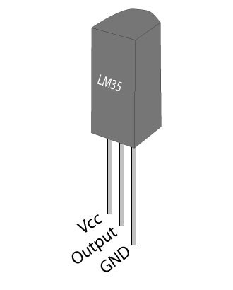

Figure 4.16: Temperature Sensor LM35

#### 4.1.12.1 Features

* Calibrated Directly in Celsius (Centigrade)
* Linear + 10-mV/°C Scale Factor
* 0.5°C Ensured Accuracy (at 25°C)
* Rated for Full −55°C to 150°C Range
* Suitable for Remote Applications
* Low-Cost Due to Wafer-Level Trimming
* Operates from 4 V to 30 V
* Less than 60-μA Current Drain
* Low Self-Heating, 0.08°C in Still Air
* Non-Linearity Only ±¼°C Typical
* Low-Impedance Output, 0.1 Ω for 1-mA Load

 The operating temperature range is from -55°C to 150°C. The output voltage varies by 10mV in response to every **o**C rise/fall in ambient temperature, *i.e.,* its scale factor is 0.01V/**o**C.

#### 4.1.12.2 Pin Description

|  |  |  |
| --- | --- | --- |
| **Pin No** | **Function** | **Name** |
| 1 | Supply voltage; 5V (+35V to -2V) | Vcc |
| 2 | Output voltage (+6V to -1V) | Output |
| 3 | Ground (0V) | Ground |

Table 4.5: Pin Description of Temperature Sensor LM35

#### 4.1.12.3 Working

Here is the internal circuit of an LM-35 temperature sensor. The working can be described as follows: There are two transistors in the centre of the drawing. One has ten times the emitter area of the other. This means it has one tenth of the current density, since the same current is going through both transistors. This causes a voltage across the resistor R1 that is proportional to the absolute temperature, and is almost linear across the range we care about. The "almost" part is taken care of by a special circuit that straightens out the slightly curved graph of voltage versus temperature.

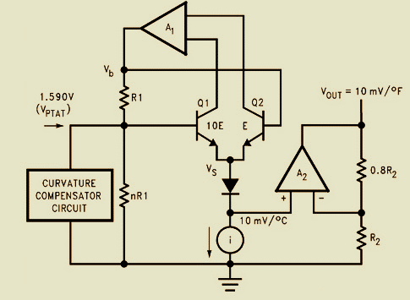

Figure 4.17: Circuit Diagram of Temperature Sensor LM35

The amplifier at the top ensures that the voltage at the base of the left transistor (Q1) is proportional to absolute temperature (PTAT) by comparing the output of the two transistors. The amplifier at the right converts absolute temperature (measured in Kelvin) into either Fahrenheit or Celsius, depending on the part (LM34 or LM35).

The two resistors are calibrated in the factory to produce a highly accurate temperature sensor. The integrated circuit has many transistors in it -- two in the middle, some in each amplifier, some in the constant current source, and some in the curvature compensation circuit. All of that is fit into the tiny package with three leads.

### 4.1.13 Voltage Regulator

The LM78XX 3-terminal positive voltage regulators employ internal current -limiting, thermal shutdown and safe-area compensation, making them essentially indestructible. Heat sinking is provided; they can deliver over 1.0A output current. They are intended as fixed voltage regulators in a wide range of applications including local(on-card) regulation for elimination of noise and distribution problems associated with single-point regulation. In addition to use as fixed voltage regulators the features of voltage regulators are as under.

* Output current up to 1 A.
* Output voltages of 5; 6; 8; 9; 12; 15; 18; 24 V .
* Thermal overload protection.
* Short circuit protection.

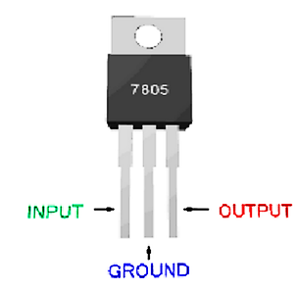

Figure 4.18: Voltage Regulator

## 4.2 Software Specifications

### 4.2.1 Arduino IDE

Installing, and testing the [Arduino software](http://arduino.cc/en/Main/Software) (also known as the Arduino IDE - short for Integrated Development Environment). Before you jump to the page for your operating system, make sure you’ve got all the right equipment.

What we will need:

* A computer (Windows, Mac, or Linux).
* An Arduino-compatible microcontroller (anything from [this guide](https://www.sparkfun.com/pages/arduino_guide) should work).
* A USB A-to-B cable, or another appropriate way to connect your Arduino-compatible microcontroller to your computer.

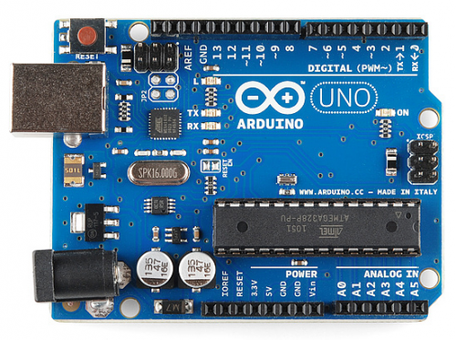

Figure 4.19: An Arduino Uno

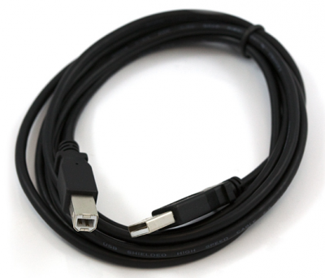

Figure 4.20: An A-to-B USB Cable

Installing the Drivers for the Arduino Uno (from Arduino.cc)

* Plug in your board and wait for Windows to begin it’s driver installation process.
* After a few moments, the process will fail, despite its best efforts.
* Click on the Start Menu, and open up the Control Panel.
* While in the Control Panel, navigate to System and Security. Next, click on System.
* Once the System window is up, open the Device Manager.
* Look under Ports (COM & LPT). You should see an open port named “Arduino UNO (COMxx)”. If there is no COM & LPT section, look under ‘Other Devices’ for ‘Unknown Device’.

Figure 4.21: Step 1 of Installation

* Right click on the “Arduino UNO (COMxx)” or “Unknown Device” port and choose the “Update Driver Software” option
* Next, choose the “Browse my computer for Driver software” option.

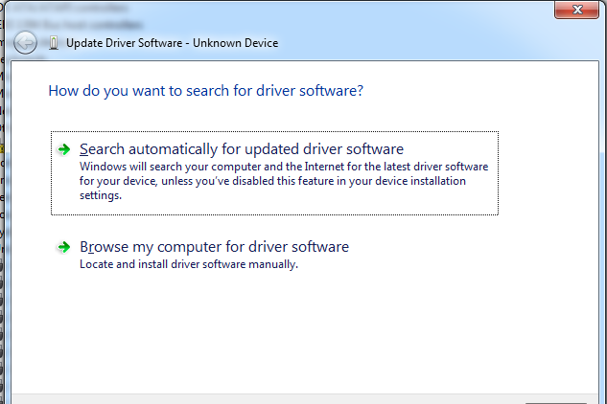

Figure 4.22: Step 2 of Installation

* Finally, navigate to and select the Uno’s driver file, named “ArduinoUNO.inf”, located in the “Drivers” folder of the Arduino Software download (not the “FTDI USB Drivers” sub-directory). If you cannot see the .inf file, it is probably just hidden. You can select the ‘drivers’ folder with the ‘search sub-folders’ option selected instead.
* Windows will finish up the driver installation from there

Software written using Arduino is called **sketches**. These sketches are written in the text editor. Sketches are saved with the file extension .ino. It has features for cutting/pasting and for searching/replacing text. The message area gives feedback while saving and exporting and also displays errors. The console displays text output by the Arduino environment including complete error messages and other information. The bottom right hand corner of the window displays the current board and serial port. The toolbar buttons allow you to verify and upload programs, create, open, and save sketches, and open the serial monitor.

|  |  |
| --- | --- |
| play | Verify  Checks your code for errors. |
| export | Upload  Compiles your code and uploads it to the Arduino I/O board. See uploading below for details. |

Table 4.6: Verification and uploading

### 4.2.2 Proteus Software

Proteus 8 is a best simulation software for various designs with microcontroller. It is mainly popular because of availability of almost all microcontrollers in it. So it is a handy tool to test programs and embedded designs for electronics hobbyist. You can simulate your programming of microcontroller in Proteus 8 Simulation Software. After simulating your circuit in Proteus 8 Software you can directly make PCB design with it so it could be a all in one package for students and hobbyists. So I think now you have a little bit idea about what is Proteus software.

PROTEUS is the database behind the deflower project. It is primarily a database of morphological traits. PROTEUS is designed as a collaborative tool, whereby users contribute data on their taxa of interest, decide whether these data are private (until publication) or shared with other users, and create and output NEXUS matrices tailored to their own needs. Like the deity from Greek mythology with the same name, PROTEUS can take many shapes: for instance, the same pool of data can take the shape of many matrices. PROTEUS is designed to track everything, in particular the original reference of any piece of information as well as the user who has entered it. In addition, PROTEUS automatisms a number of character transformations.

# Chapter 5

# Results

The advancement in technology has made it possible to have extremely small, low powered devices equipped with programmable computing, multiple parameter sensing and wireless communication capability. Also, the low cost of sensors makes it possible to have a network of hundreds or thousands of these wireless sensors, thereby enhancing the reliability, accuracy of data and the area coverage. Moreover, it is necessary that the sensors be easy to deploy i.e. require very low or no installation cost etc. These wireless sensors can be deployed (dropped from plane or placed in factory) at the site of interest without any pre-organization, thus reducing the installation cost and increasing the flexibility of arrangement.

One huge wired sensor (Macro-sensor) can be replaced by many smaller wireless sensors for the same cost. One macro-sensor can sense only a limited region whereas a network of smaller sensors can he distributed over a wider region.

Since sensor networks are mostly unattended, they should possess fault tolerant capability. With macro-sensors, the failure of one node makes that area completely unmonitored till it is replaced. Whereas with wireless sensors, failure of one node does not affect the network operation considerably as there are other nodes collecting similar data. Ai most, the accuracy of data collected may be reduced,

Since these wireless sensors are equipped with battery, they can possess limited mobility (e.g., robots). Thus, if a region becomes unmonitored we can have the nodes rearrange themselves to distribute evenly, i.e., these nodes can be made to move towards area of interest. Note, however, that these nodes have lower mobility as compared to ad hoc networks.

There are a few inherent limitations of wireless medium such as low bandwidth, error prone transmissions, need for collision free channel access, etc. It is clear due to the nature of observed phenomenon; the required bandwidth of sensor data will be low, on the order of I -100 kb/s. Since the wireless nodes are mostly mobile and are not connected in any way to a constant power supply, they derive energy from a personal battery. This limits the amount of energy available to the nodes. In addition, since these sensor nodes are deployed in places where it is difficult to either replace the nodes or their batteries, it is desirable to increase the longevity of the network and, preferably, all the nodes should die together so that we can replace all the nodes simultaneously or put new nodes on the whole area. Finding individual dead nodes and then replacing those nodes selectively would require pre-planned deployment and eliminates some advantages of these networks. Thus, the protocols designed for these networks must strategically distribute the dissipation of energy, which also increases the average life of the overall system. In addition, environments in which these nodes operate and respond are very dynamic, with fast changing physical parameters.

In traditional wired and wireless networks, each node is given a unique id, used for routing. This cannot be effectively used in sensor networks because these networks, being data centric, routing to anti from specific nodes is not required. . Adjacent nodes may have similar data. So, rather than sending data separately from each node to the requesting node, it is desirable to aggregate similar data before sending it. The requirements of the network change with the application and hence. It is application-specific. For example, in some applications the sensor nodes are fixed and not mobile while others may need data based only on one selected attribute.

# Chapter 6

# Conclussion

The overall hardware and software approaches has been fulfilled accordingly, the designed system works properly. It is stated that the basic theme of our project is to design a wireless sensor ad-hoc network using some kind of electrical devices which will do the sensing task to intercept the incoming signal, then finding the light intensity and temperature of the environment.

The designed project for wireless sensor Ad-hoc Network is capable of:

* The present setup can easily sense the temperature of the environment in which it is present.
* The sensor of the designed ad-hoc network can detects the light intensity and transfer the message about light intensity and LEDs start blinking when the motion pulse occurs in the environment.
* Present study defines the Ad-hoc network purely and this approach can be used in several security systems and Military purposes.

Ad-hoc Networks are an ideal technology to establish in an instant communication infrastructure less for military application. ZigBee is one of the newest technologies enabling Wireless Personal Area Networks (WPAN). ZigBee is an established set of specifications for wireless personal area networking (WPAN), i.e. digital radio connections between computers and related devices. WPAN Low Rate or ZigBee provides specifications for devices that have low data rates, consume very low power and are thus characterized by long battery life. ZigBee makes possible completely networked homes where all devices are able to communicate and be controlled by a single unit.

The IEEE 802.15.4 standard and ZigBee wireless technology are designed to satisfy the market's need for a low-cost, standard-based and flexible wireless network technology, which offers low power consumption, reliability, interoperability and security for control and monitoring applications with low to moderate data rates.

The data which gets transmitted includes temperature reading on or off state of a switch keystroke of a keyboard etc. The Bluetooth technology which is used in mobile phones, laptops, runs on ZigBee. ZigBee is an IEEE 802.15.4 standard. ZigBee operates in a frequency range 900MHz- 2.5 GHz. The technology can be used for transmitting the data within the range of 20mts. It can also be used for transmission of data within a range greater than 20mts. This is possible through the intermediate nodes.

Habitat and environmental monitoring represent an important class of sensor network applications. The air conditioning and heat of most buildings are centrally controlled. Therefore, the temperature inside a room can vary by few degrees; one side might be warmer than the other because there is only one control in the room and the air flow from the central system is not evenly distributed. A distributed wireless sensor network system can be installed to control the air flow and temperature in different parts of the room.

The fast pace of which mobile technology evolves will probably resolution new demands. Many of those demands will probably be satisfied by the development of robust, effective and cheap ad-hoc networks. These new technologies will make it possible to establish robust network on demand and no further equipment will be needed. Ad-hoc technologies will also prove useful in situations where the infrastructure has been destroyed.

Some of the commercial applications of wireless ad hock network are monitoring material fatigue; building virtual keyboards; managing inventory; monitoring product quality; constructing smart office spaces; environmental control in office buildings; robot control and guidance in automatic manufacturing environments; interactive toys; interactive museums; factory process control and automation; monitoring disaster area; smart structures with sensor nodes embedded inside; machine diagnosis; transportation; factory instrumentation; local control of actuators; detecting and monitoring car thefts; vehicle tracking and detection; and instrumentation of semiconductor processing chambers, rotating machinery, wind tunnels, and anechoic chambers.

# References

1. J. Lansford, P. Bahl, “The Design and Implementation of HomeRF: A Radio Frequency Wireless Networking Standard For The Connected Home.” Proceedings of the IEEE, vol. 88, (no. 10), pp. 1662-76, Oct. 2000.
2. J. Haartsen, S. Mattisson, “Bluetooth - A New Low-Power Radio Interface Providing Short-Range Connectivity.” Proceedings of the IEEE, vol. 88, (no. 10), pp. 1651-61, Oct. 2000.
3. L. M. Feeney and M. Nilsson, “Investigating the energy consumption of a wireless network interface in an ad hoc networking environment,” in IEEE INFOCOM, 2001.
4. Muaz Niazi, Amir Hussain (2011). A Novel Agent-Based Simulation Framework for Sensing in Complex Adaptive Environments. IEEE Sensors Journal, Vol.11 No. 2, 404–412.
5. S.Chessa, P.Santi, “Comparison Based System-Level Fault Diagnosis in Ad-Hoc Networks”, Proc. IEEE 20th Symp. on Reliable Distributed Systems (SRDS), New Orleans, pp. 257-266, October 2001.
6. European Telecommunications Standards Institute. 2011. Archived from the original on 5 May 2011. Retrieved 5 May 2011. GSM was designed principally for voice telephony, but a range of bearer services was defined...allowing circuit-switched data connections at up to 9600 bits/s.
7. Brasche, G., Walke, B.: Concepts, Services, and Protocols of the new GSM Phase 2+ General Packet Radio Service, IEEE Communications Magazine, pp. 94-104, August 1997.
8. Wireless Application Protocol Forum. WAP Wireless Transport Layer Security. <http://www1.wapforum.org/tech/documents/> WAP-261-WTLS-20010406-a.pdf.
9. A.Daneels, W.Salter, "Selecting and Evaluation of Commercial SCADA Systems for the Controls of the CERN LHC Experiments", this Conference.
10. C. Kang, M. Golay, “An Integrated Method for Comprehensive Sensor Network Development in Complex Power Plant Systems.” Reliability Engineering & System Safety, vol. 67, pp. 17-27, Jan. 2000.
11. http://www.electronics-tutorials.ws/resistor/res_1.html.
12. http://www.learningaboutelectronics.com/images/SPDT-relay-diagram.png.
13. http://www.electronicshub.org/understanding-7805-ic-voltage-regulator/.
14. http://www.globalspec.com/industrial-directory/7812_voltage_regulator_ic.
15. www.eletrica.ufpr.br/ufpr2/professor/36/TE215/**2N2222.**
16. <http://electronics.howstuffworks.com/question537.html>.